Deli Caffe

Luis Miranda

# Restaurant Concept

**Restaurant Name & URL**

Deli Caffe

delicaffe.com

**Food & drink**

Coffee

*Customization*

* Coffee
  + Black coffee
  + Cappuccino
  + Latte
  + Americano
  + Espresso
  + Macchiato
  + Mocha
* Bread
  + Toasted in a form of a cat.
  + Toasted in a form of a dog.
  + Toasted in a form of a ferret.
  + Potato bread
  + Soda bread
  + Whole wheat
* Added
  + Fried eggs
  + Cheddar cheese
  + Salad
  + Muffins
  + Chocolate cookies

**Location**

United States, Utah, Salt Lake City (Urban)

**Main target audience**

* College students: Students who want a relaxing space between studying hours.

**Cost**

$$ - Moderate

**Elevator pitch**

A comfy caffe where you can relax alone or with friends. This caffe offers an experience that will take all your stress from outside and have your favorite meals in a calm and safe ambient.

# Strategy

## Target Audience

The website/app will focus on the following target audiences:

**Roles** (groups of people with similar goals)

* Students who look for a place to relax
* Students who want to taste a big variety of coffee.

**Demographics**

* **Gender** - Female
* **Education** – College Education
* **Occupations** – Students
* **Age** – 18-30
* **Location** – Urban, Salt Lake City area

**Psychographics** (personality, values, attitudes, interests, lifestyles)

* **Personality & Attitudes:** 
  + Classy
  + Extroverted
* **Values:** 
  + Liberal
  + Open minded
* **Lifestyles:**
  + Shopping regularly
  + Trend follower

# 

# Strategy

## User Personas (optional)



**Jane (23) – Student who looks for a place to relax.**

* Computer sciences student.
* She likes to have her own workspace.
* “I’d like to have more time for my hobbies”.
* She loves having a cappuccino every morning.



**Angela (25) – Student who wants to taste a big variety of coffee.**

* She likes to go outside with her friends.
* Wants to be on every popular trend.
* Shares every experience on social media.
* “I’d like to discover new things every day”.

# 

# Strategy

## User Needs

The website needs to enable the user to:

* Find out if the restaurant delivers to their area.
* Order food online.
* Use a cute interface.
* Have the order prepared when they get to the restaurant/home.
* Get to know where the delivery is in every moment.
* Estimate the time that it will take an order.
* Have recommendations according to your likings.

## Client Needs

The website needs to enable the client to:

* To sell food online that will be delivered.
* Provide a system for order customization.
* Get to know the likings of regular customers.
* Have information about the delivery in every moment.
* Have a tool to analyze the most liked combos.

# Outline of Scope

## Content Requirements

Content (text, images, video) that the user will need.   
*“The user will be looking for…”*

* Information about what time does the restaurant is open or closed.
* A map where it shows where the delivery is.
* An estimated time for the arrival of the delivery.
* Food menu.
  + Coffee
  + Bread
  + Added
* Photos from the local.
* Reviews.
* Address of the local.
* Contact number for the local and delivery.
* Recommendations for combos.
* The price of the order.

## Functionality Requirements

Systems that will allow the user accomplish tasks.

*“The user will be able to…”*

* Customize their order with every combination they like.
* Make a review for the food and the local.
* Make an order.
  + Indicate if they want the food on the local or on a specific location.
  + Bring their contact information.
  + Make the payment.
* Cancel their order.
* Create an account.
* Change their account.

# Sitemap

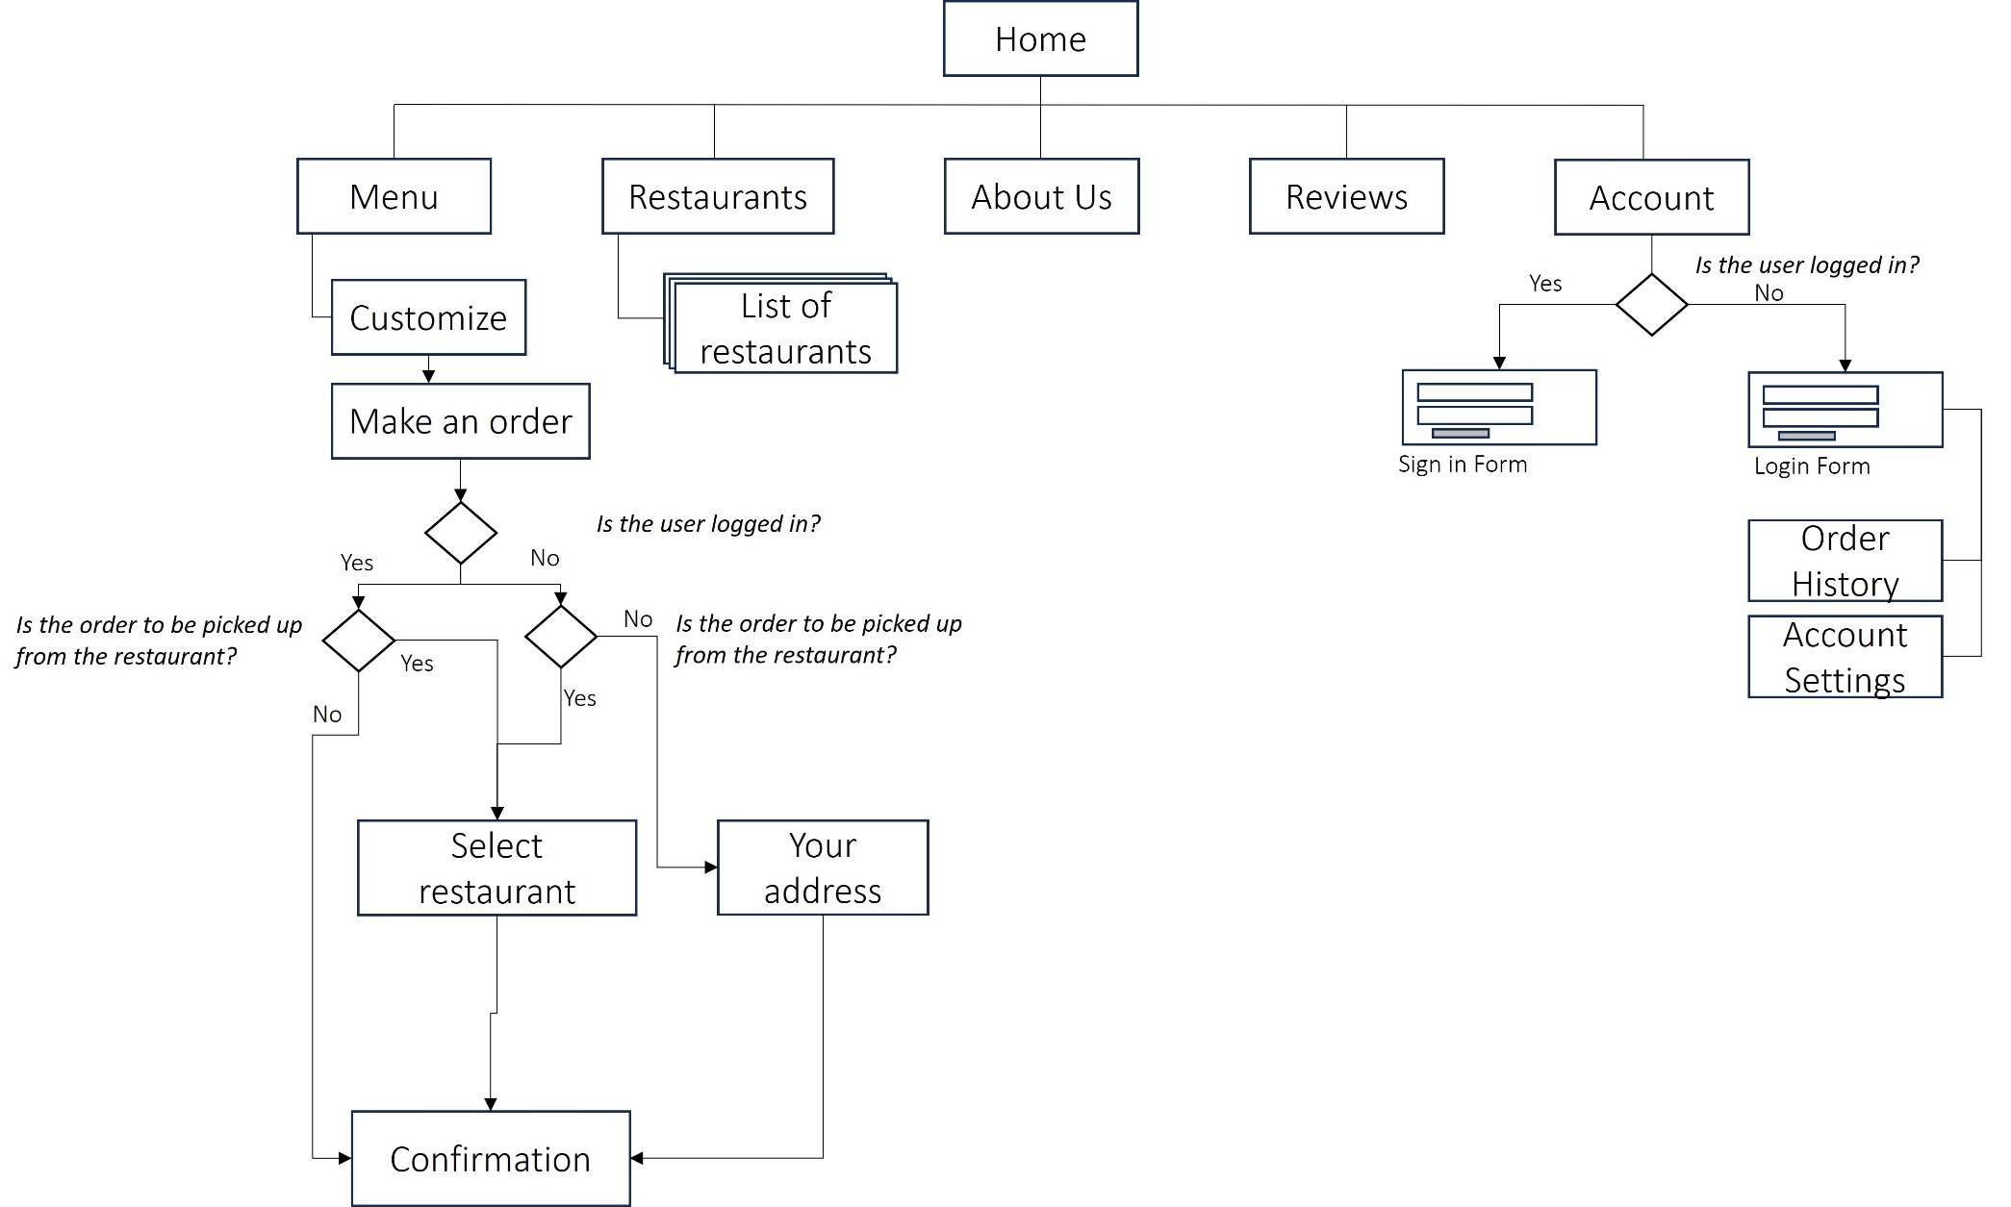

# Wireframes

## Home (PC)

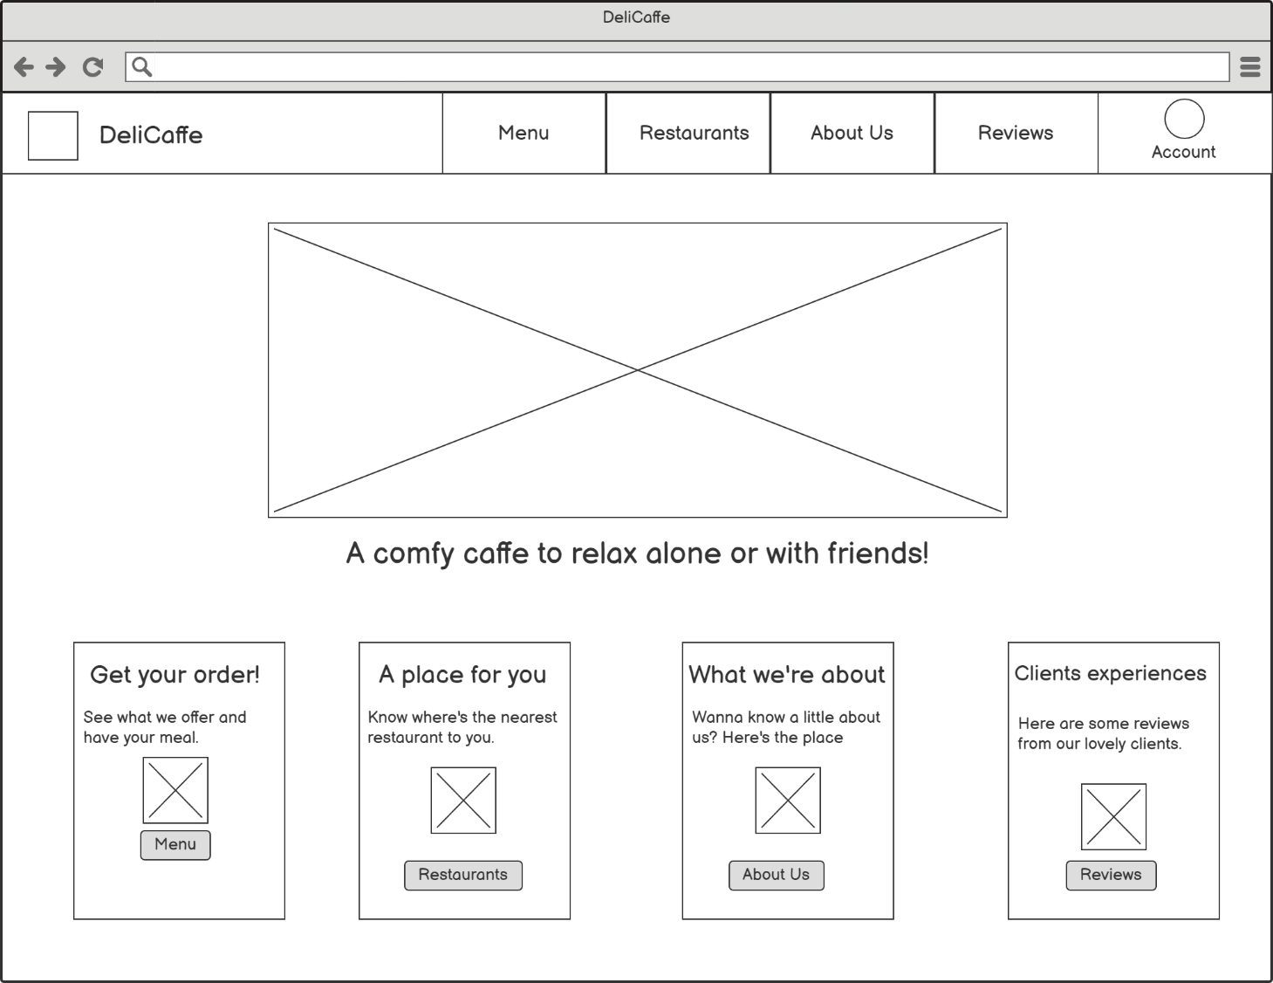

## Home (mobile)

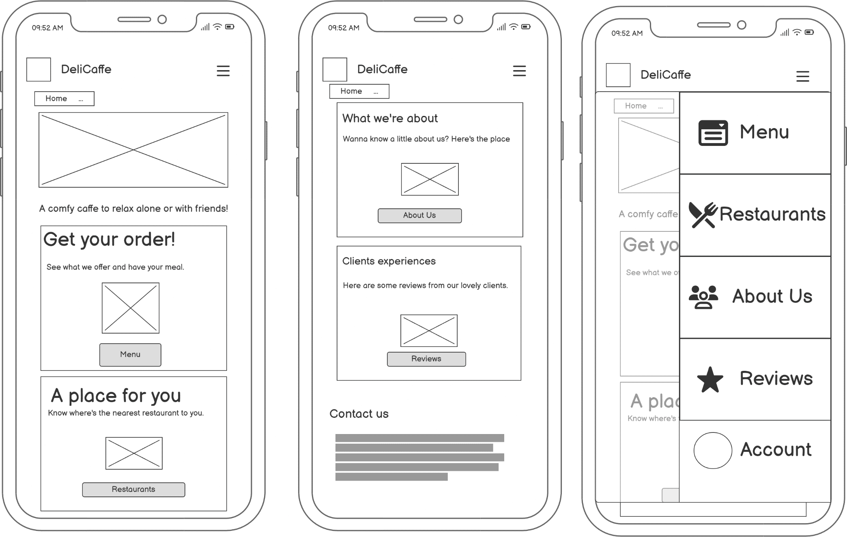





## Menu

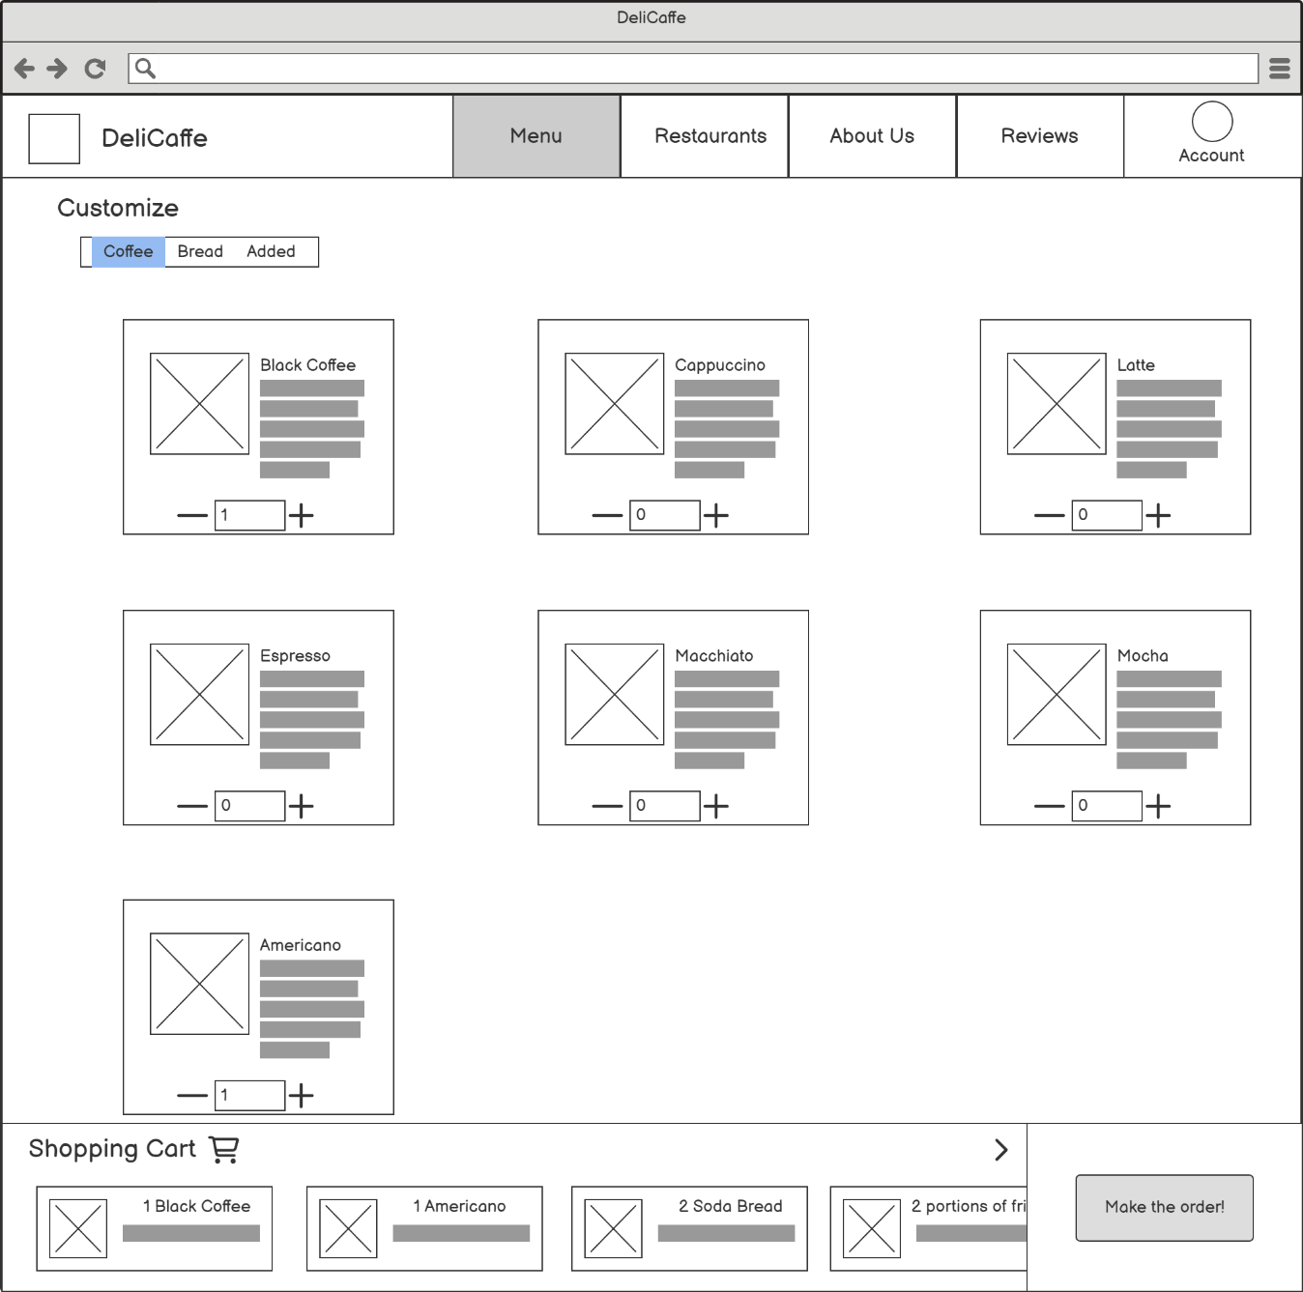

## Make an Order

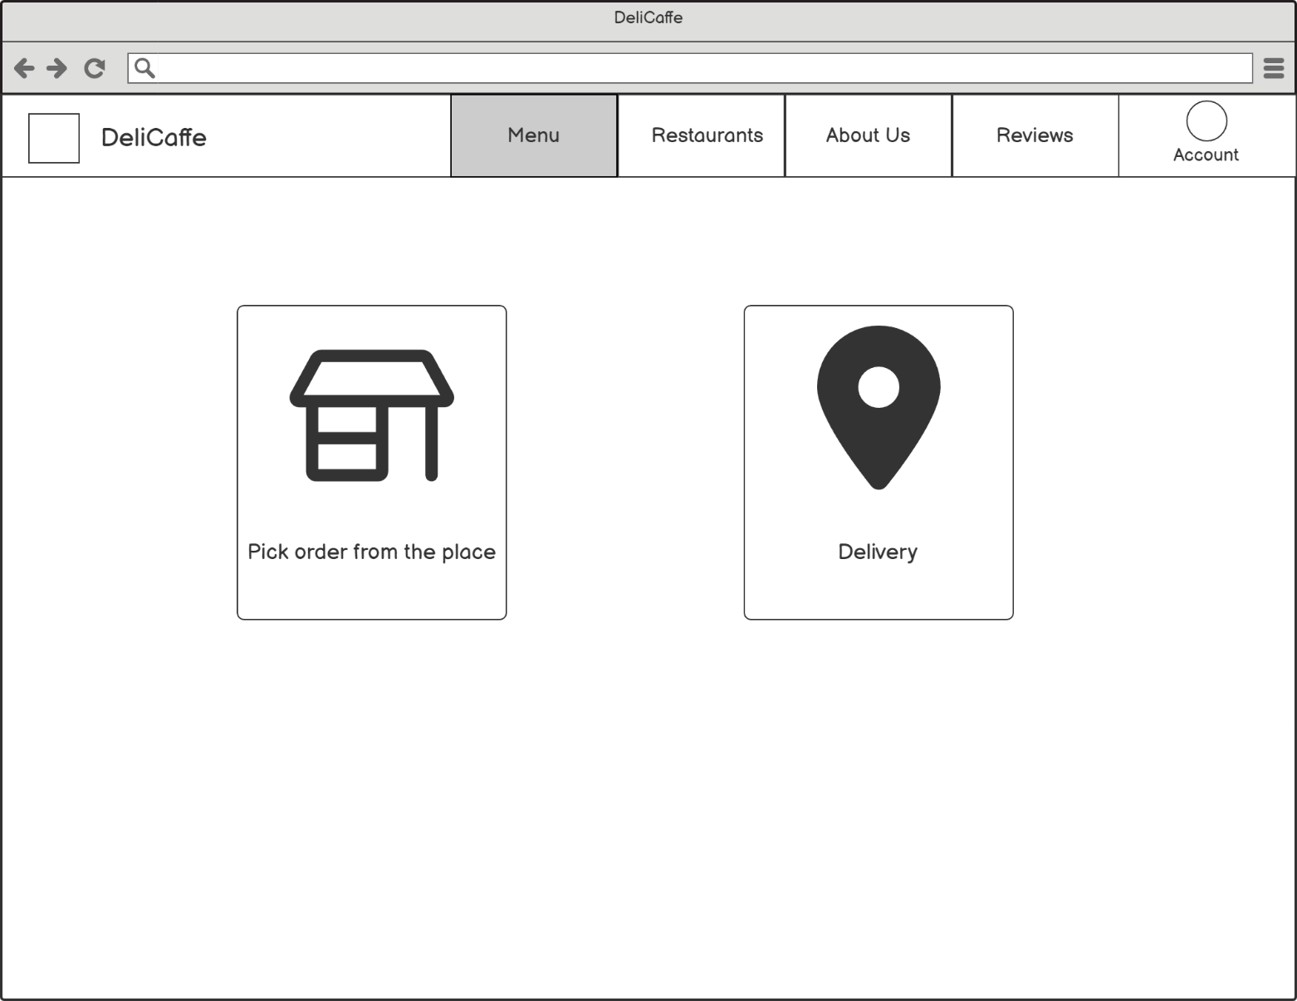

## Select Restaurant

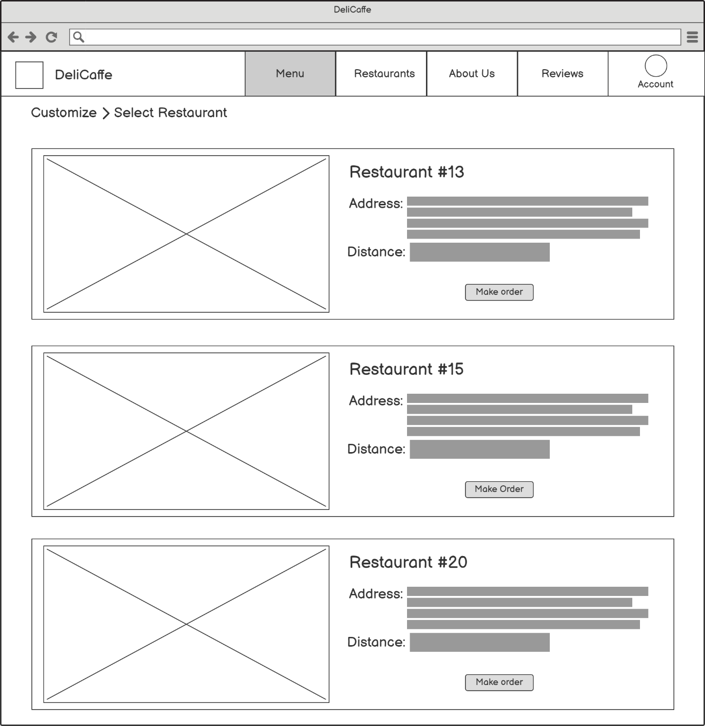

## Select Address

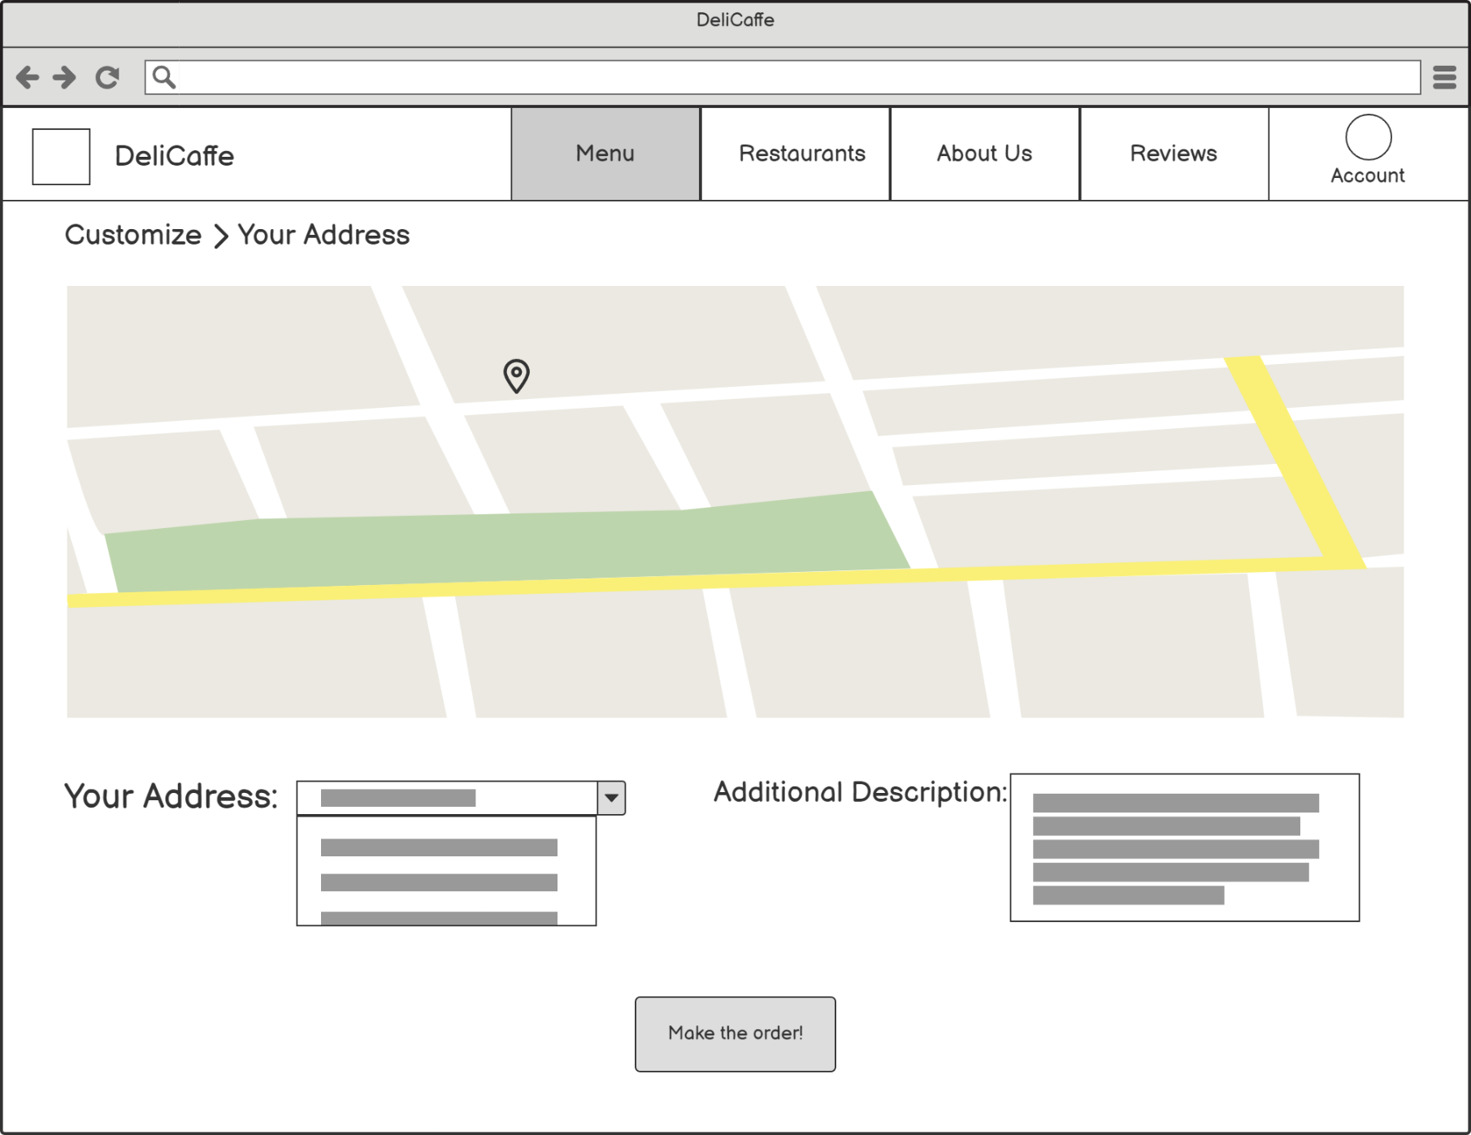

## Confirmation

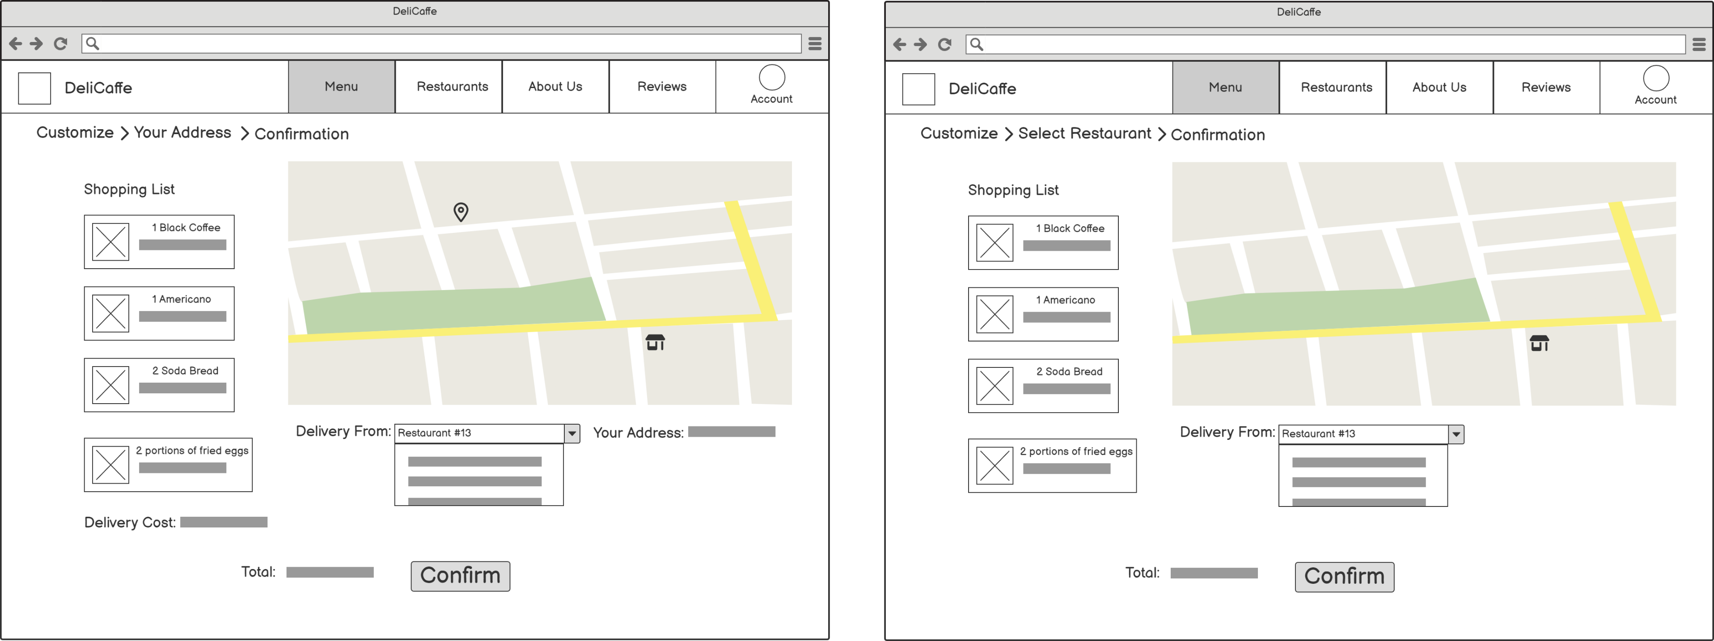

## 

## Restaurants

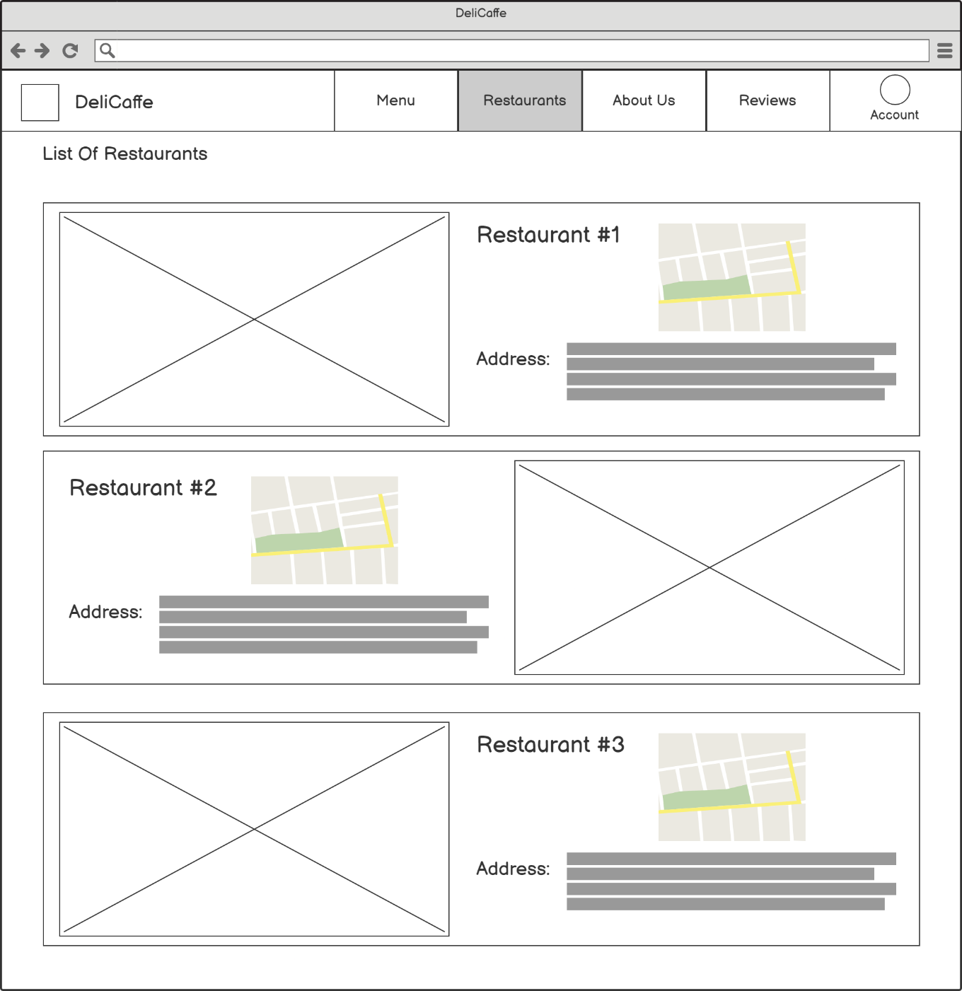

## About Us

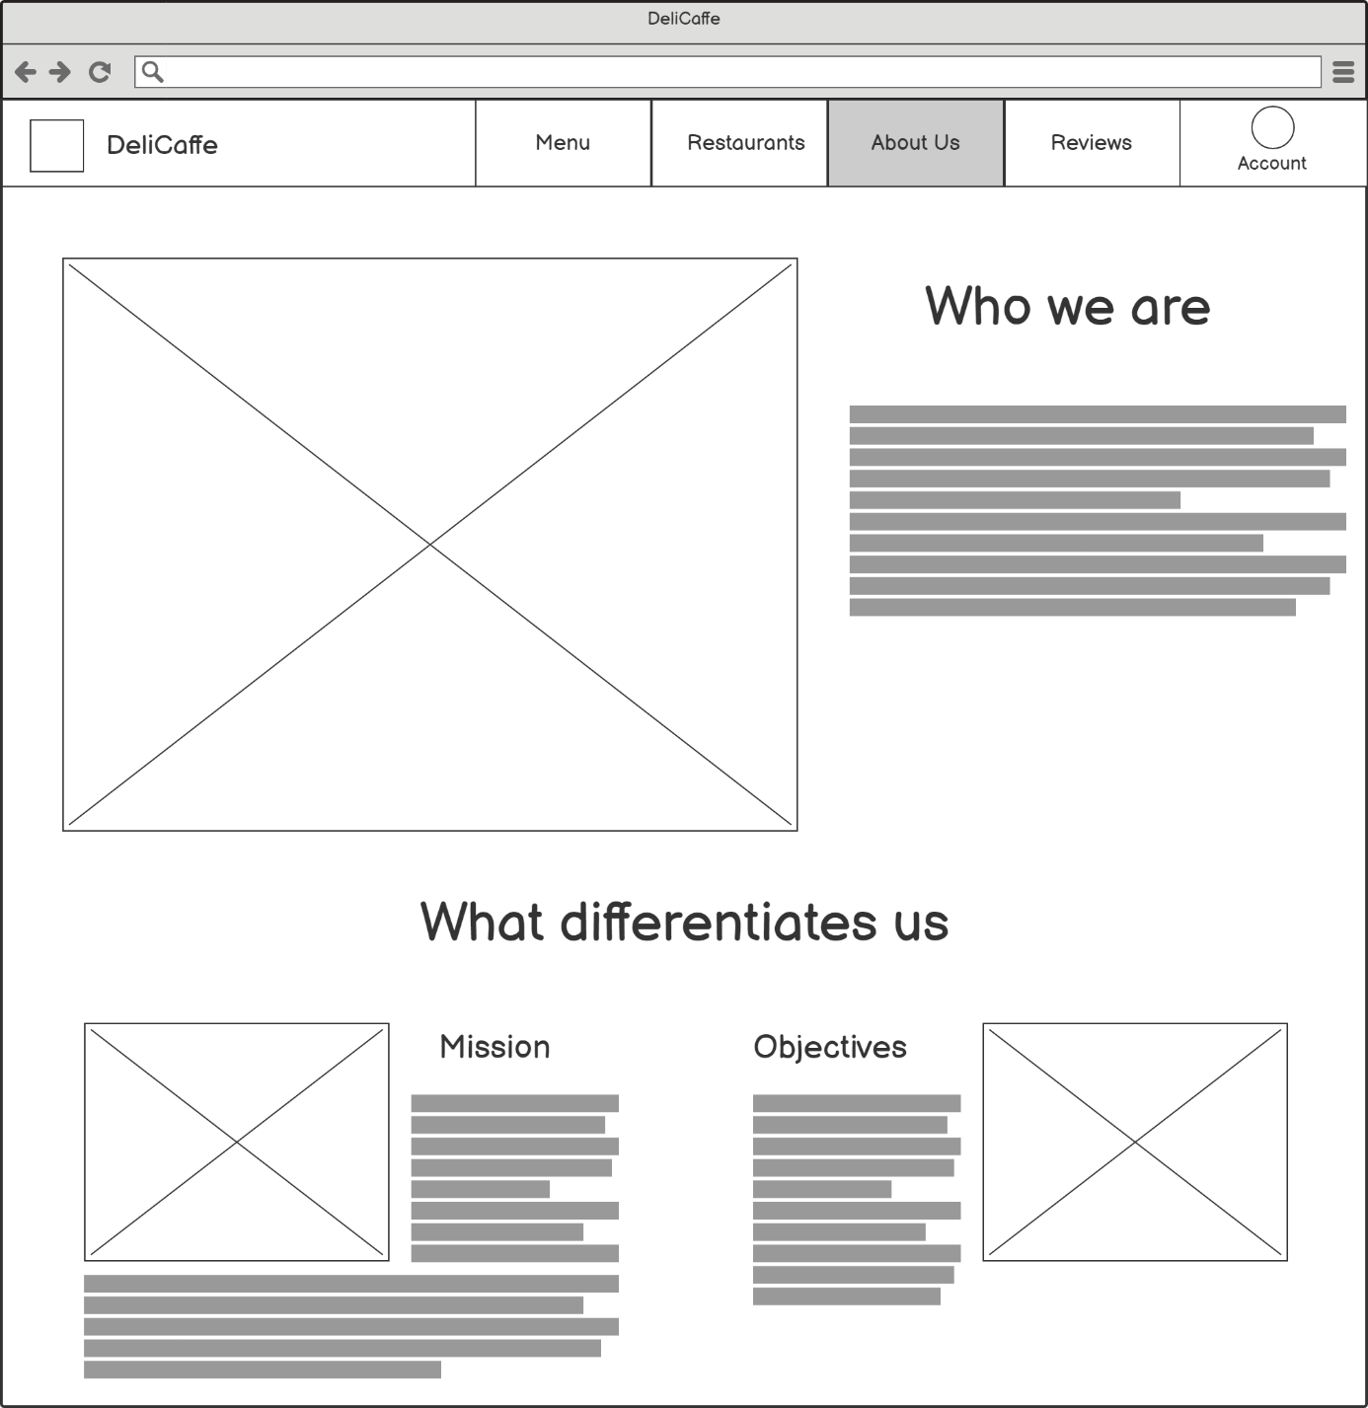

## Reviews

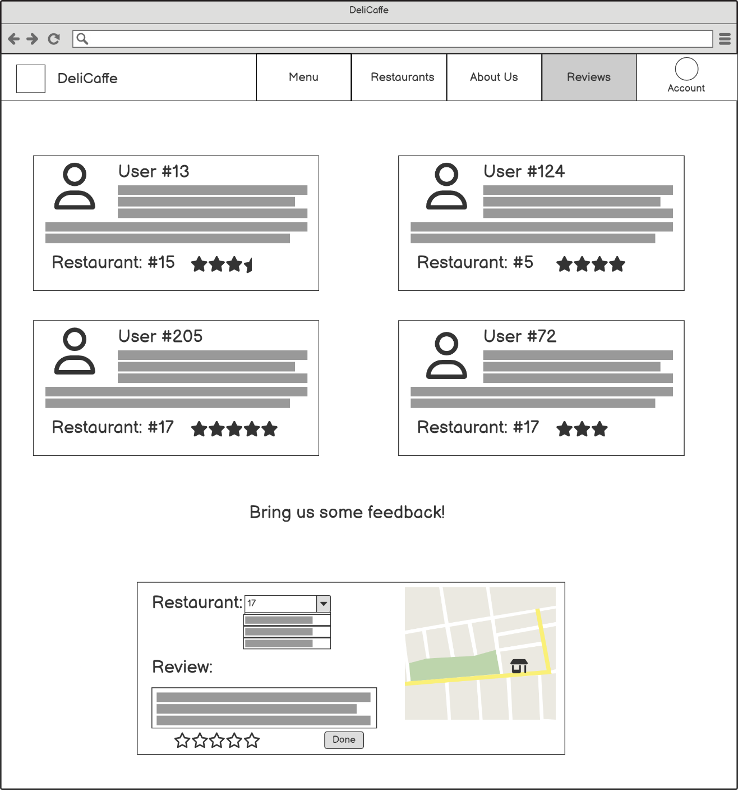

## Account

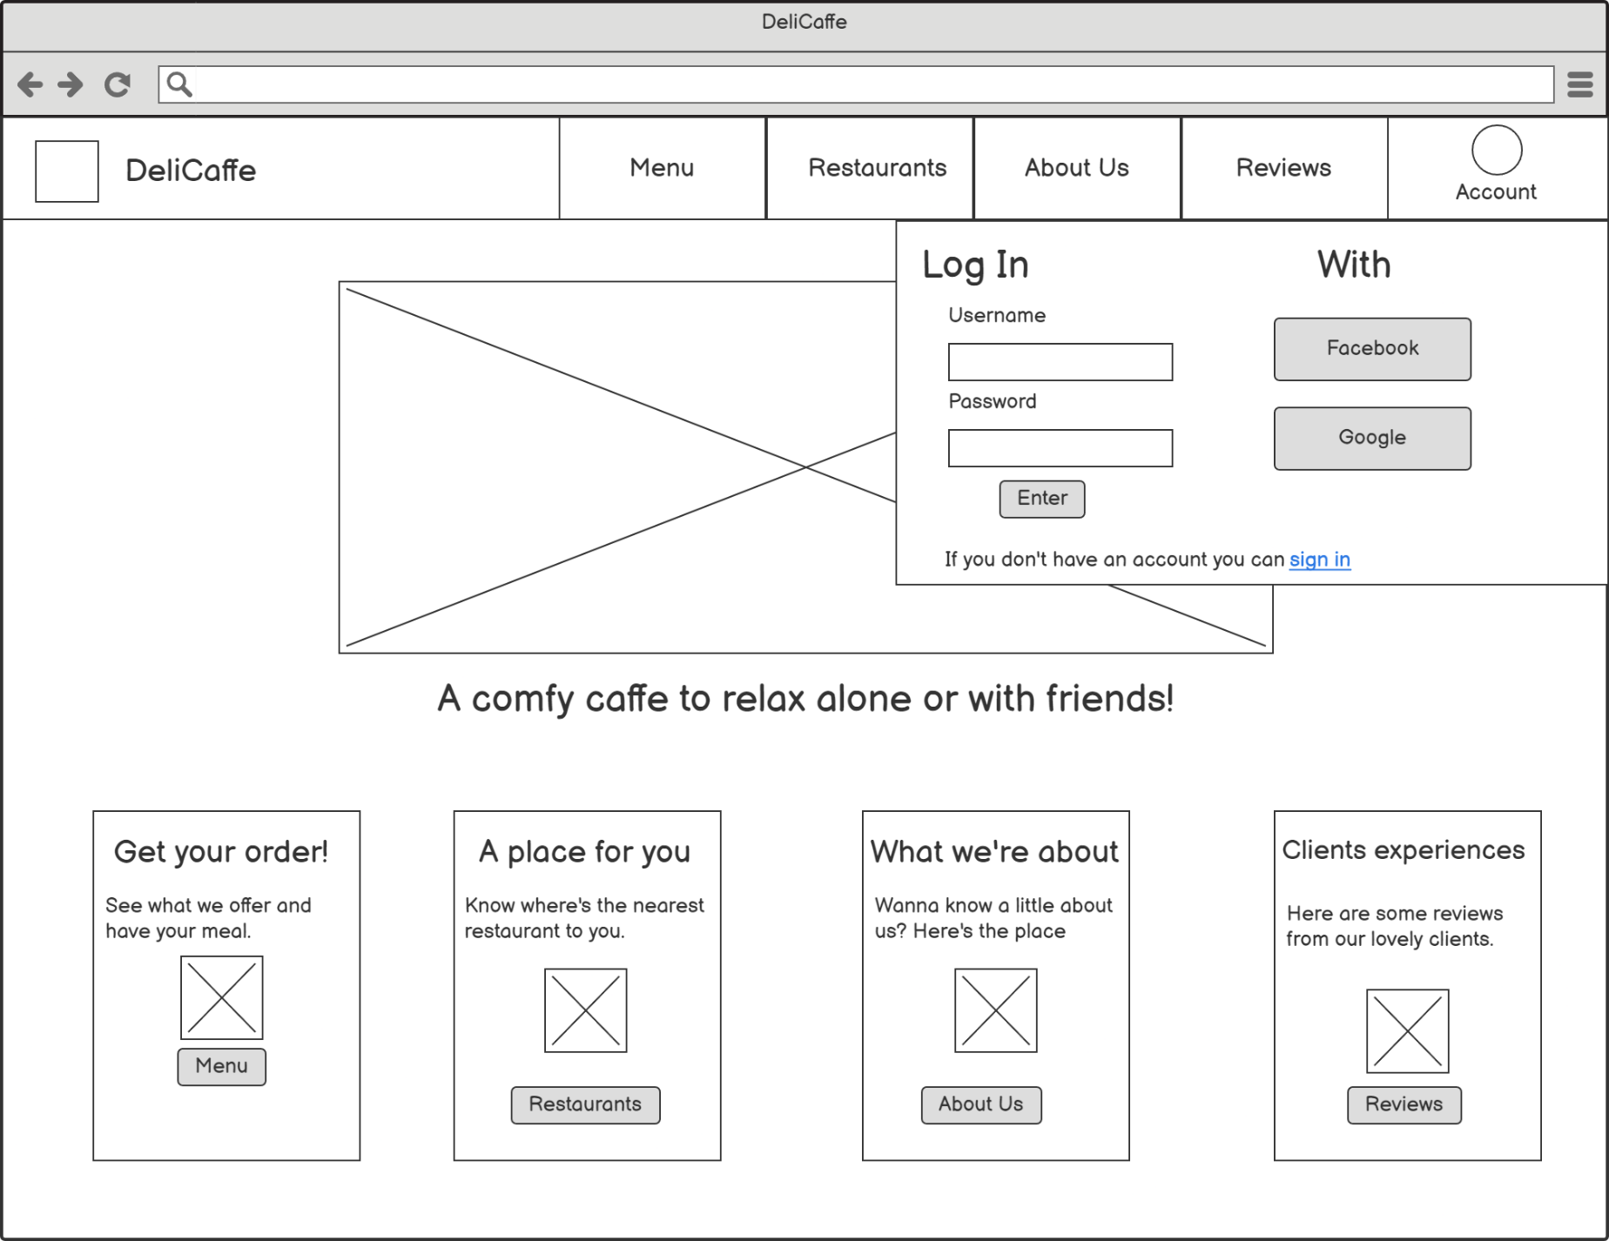

## Order History

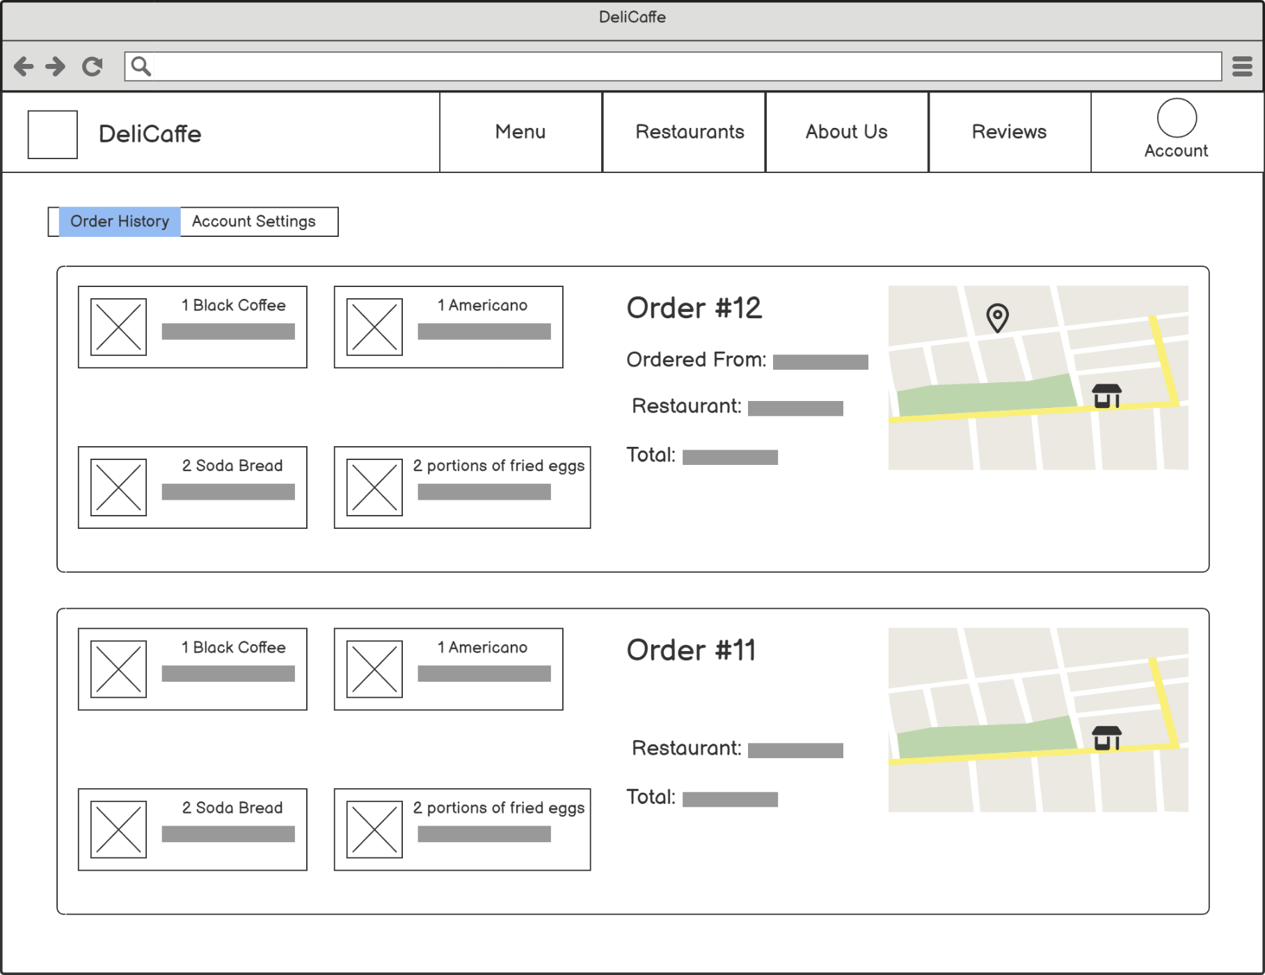

## Account Settings

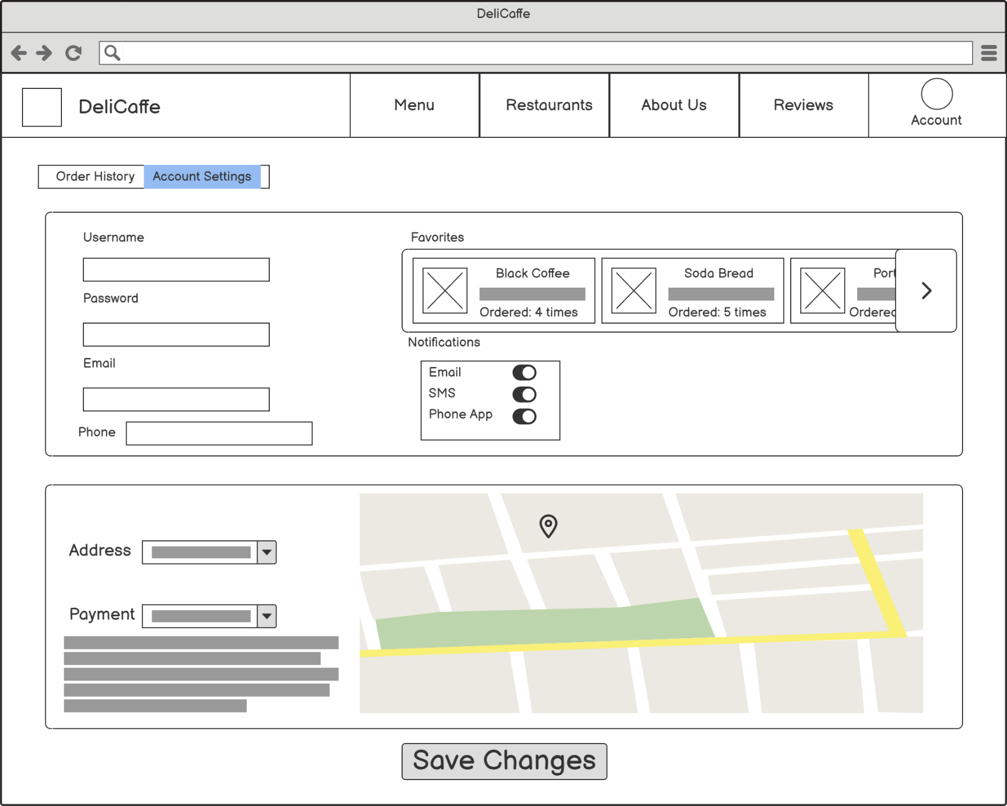

## Sign In Form

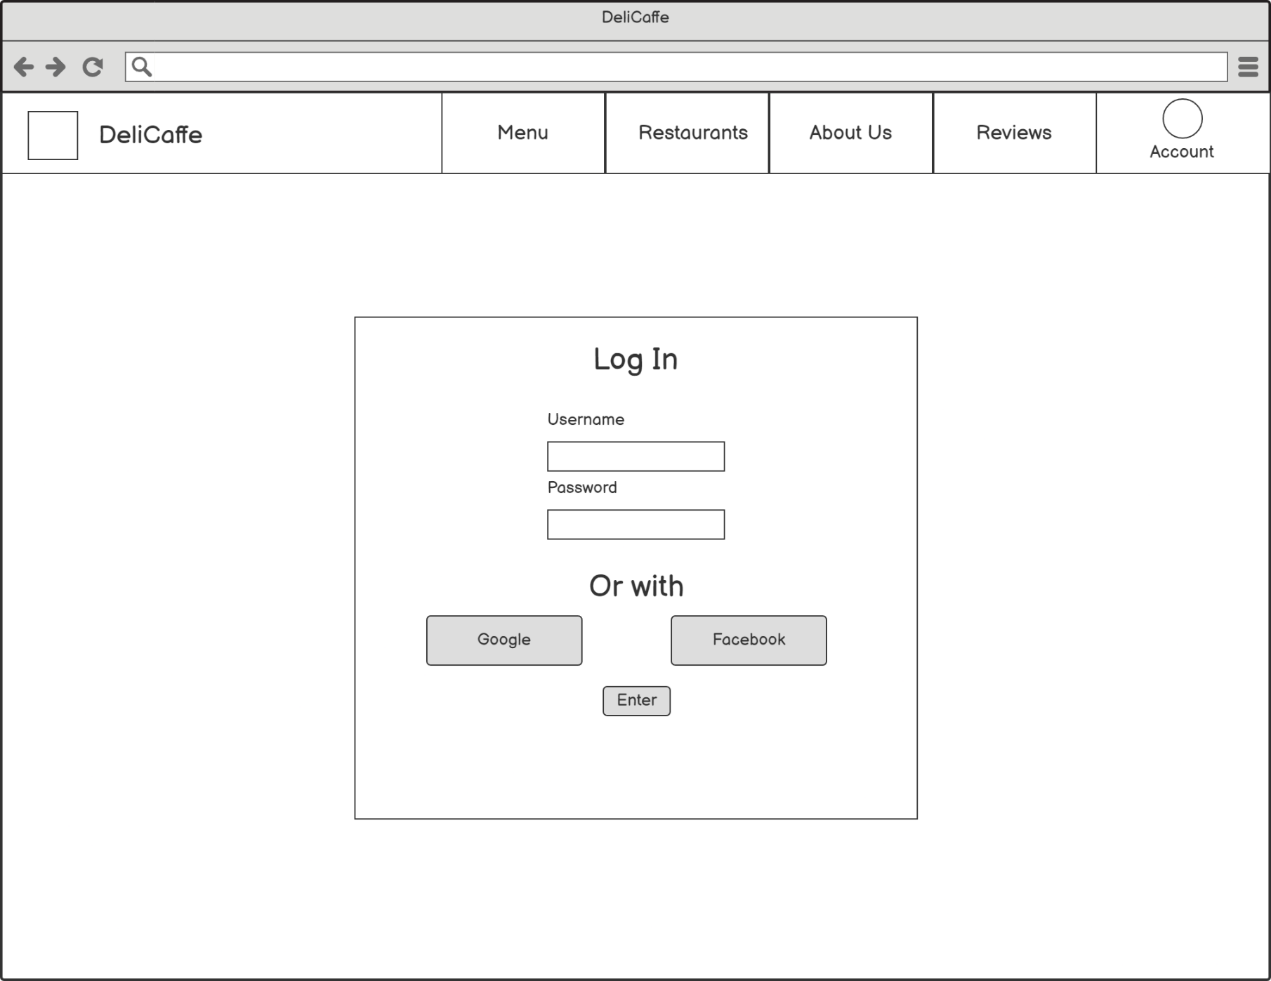

# Mood Board



# Mockups

## Home (PC)

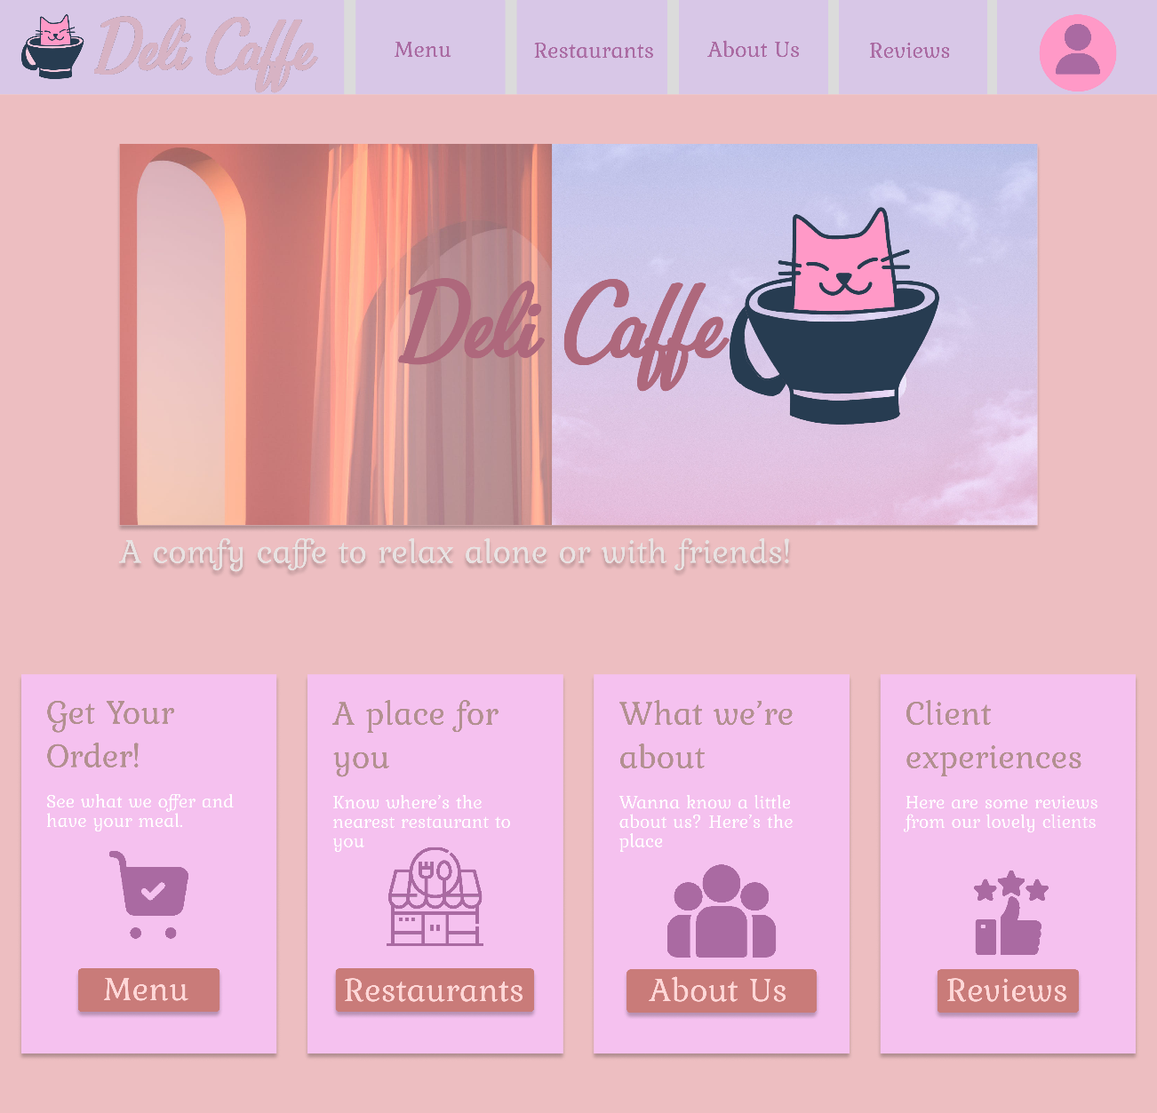

## Home (Mobile)

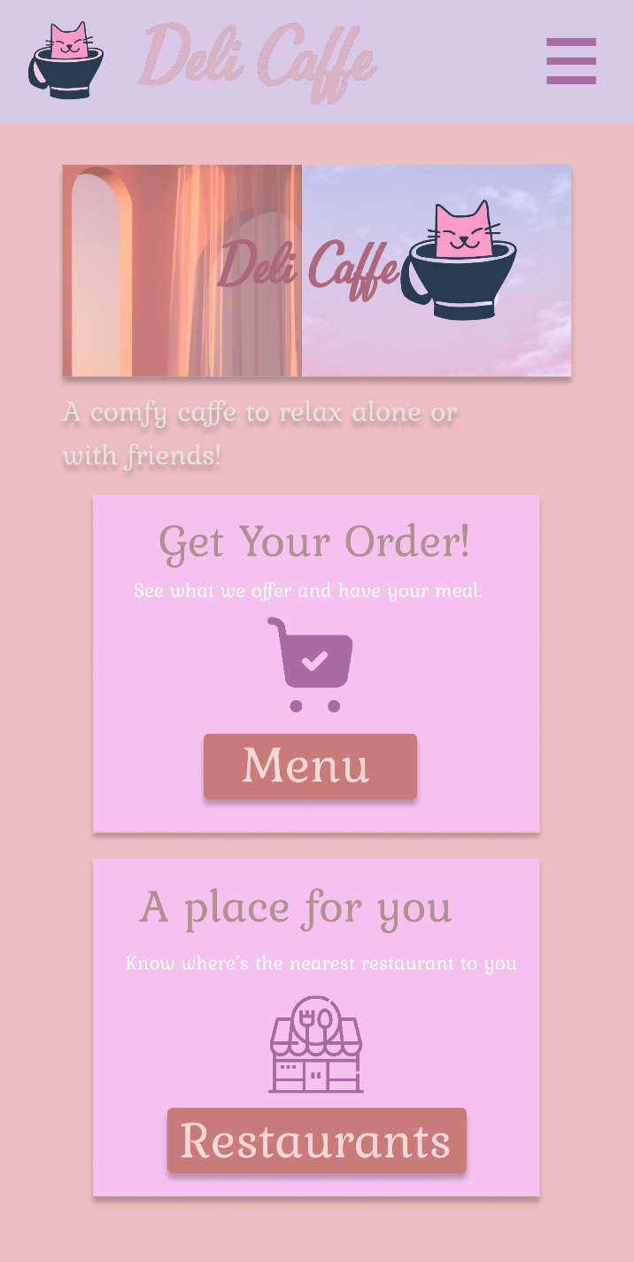

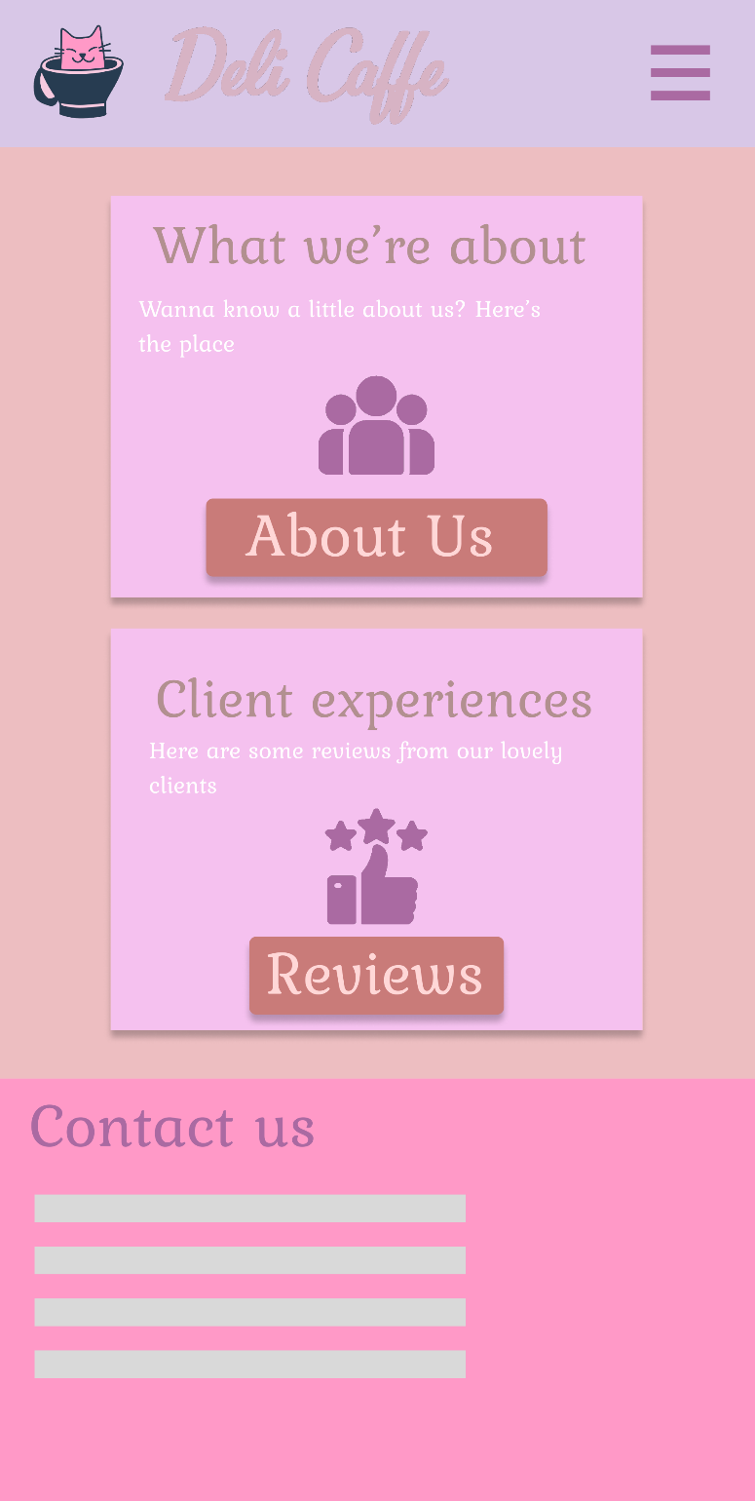

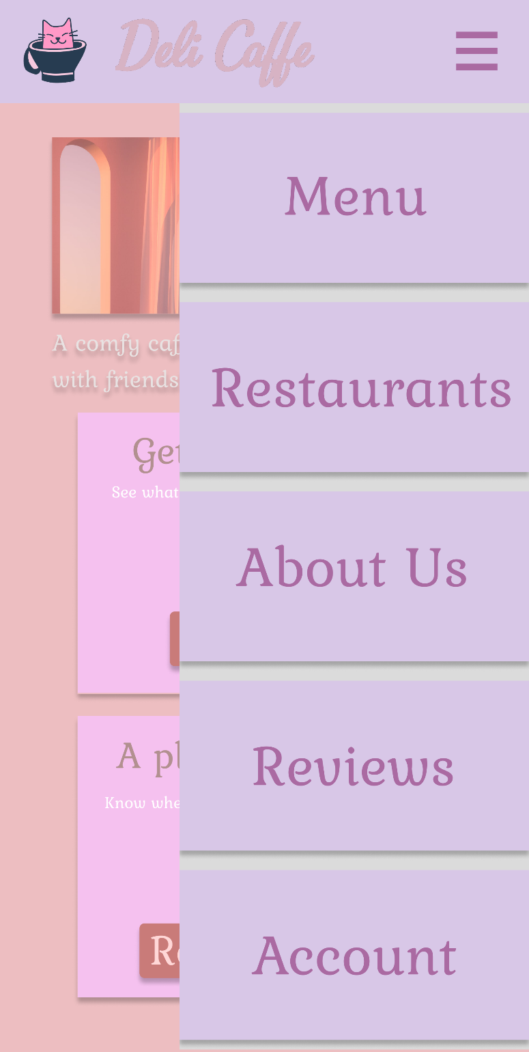

## Menu

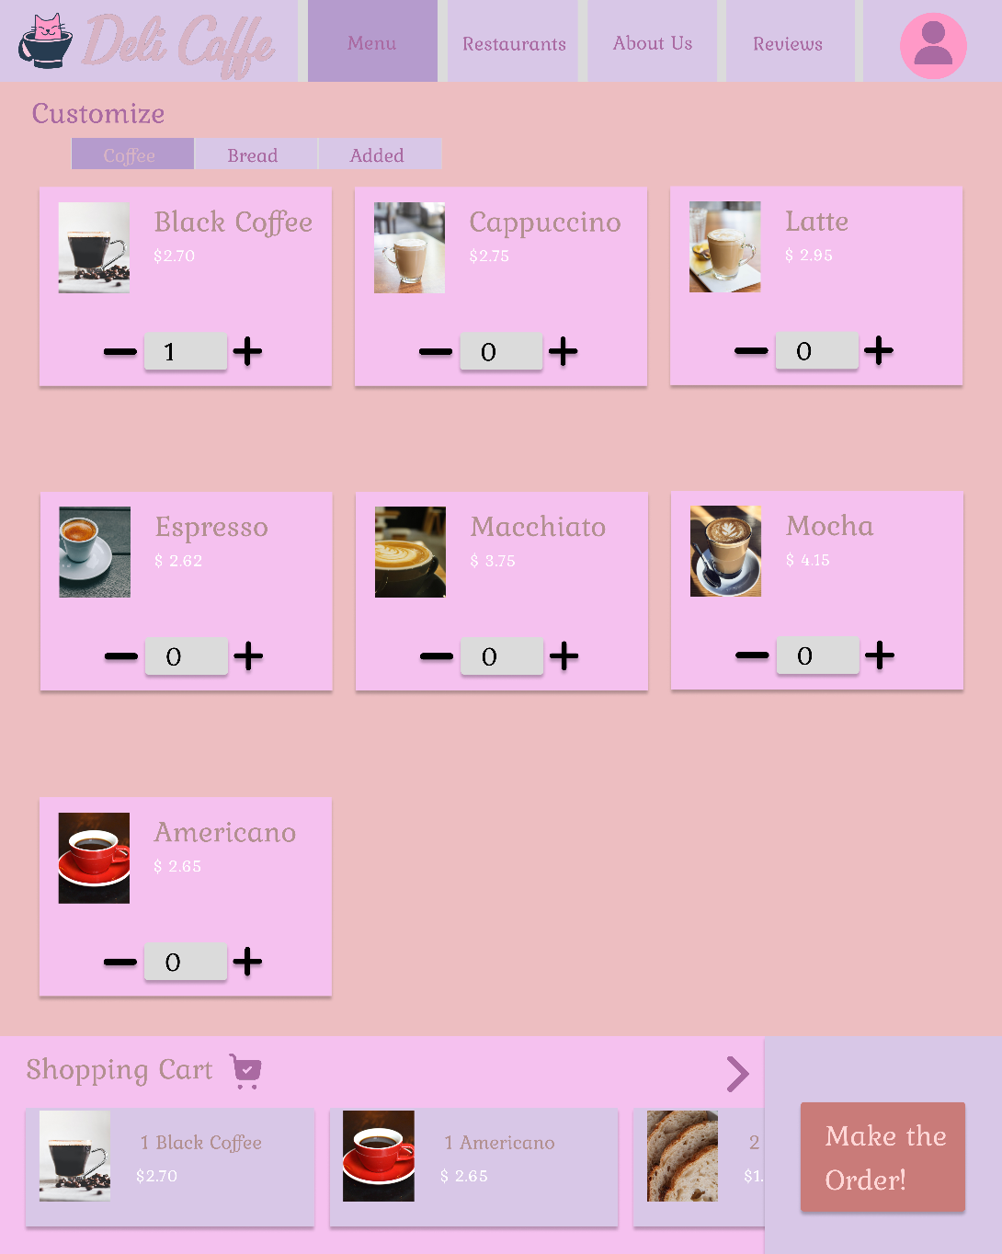

## Make An Order

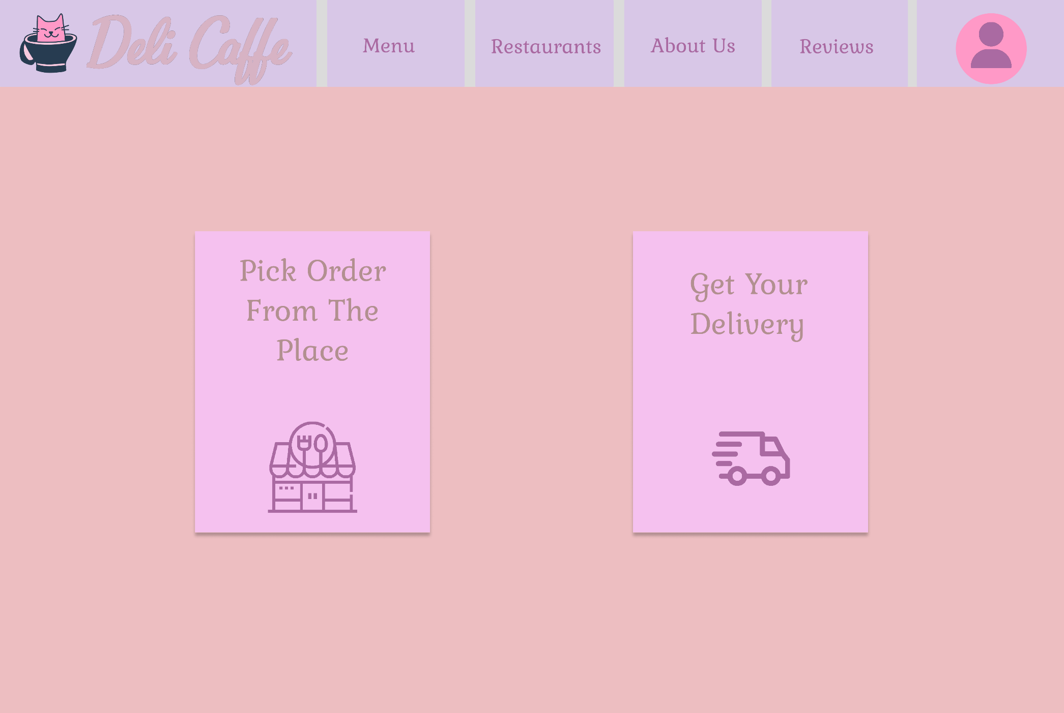

Select Restaurant

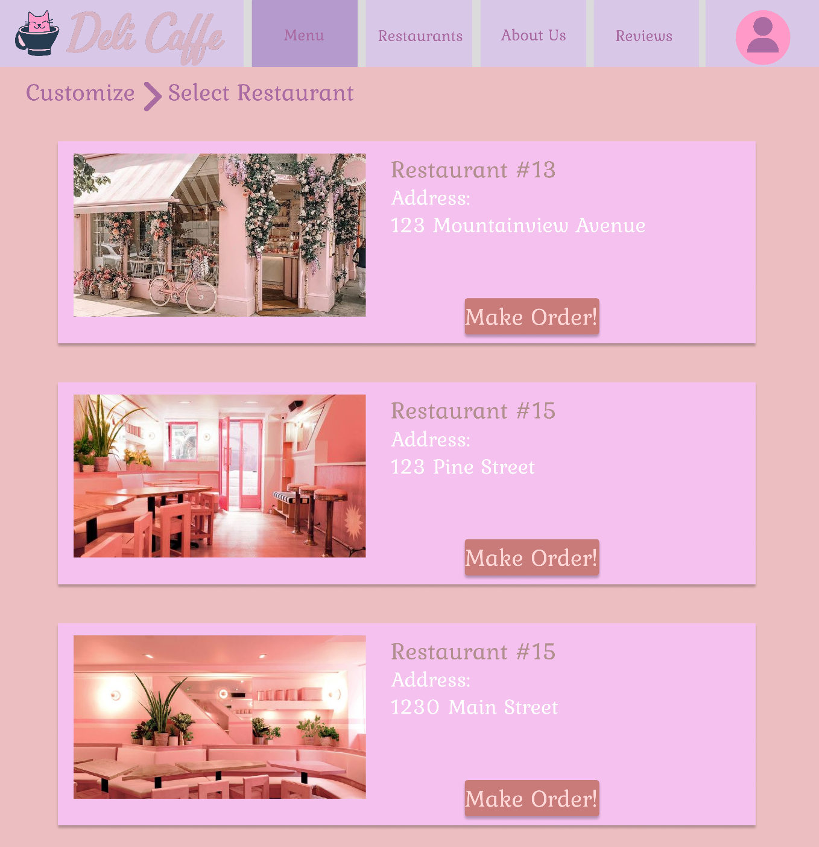

Select Address

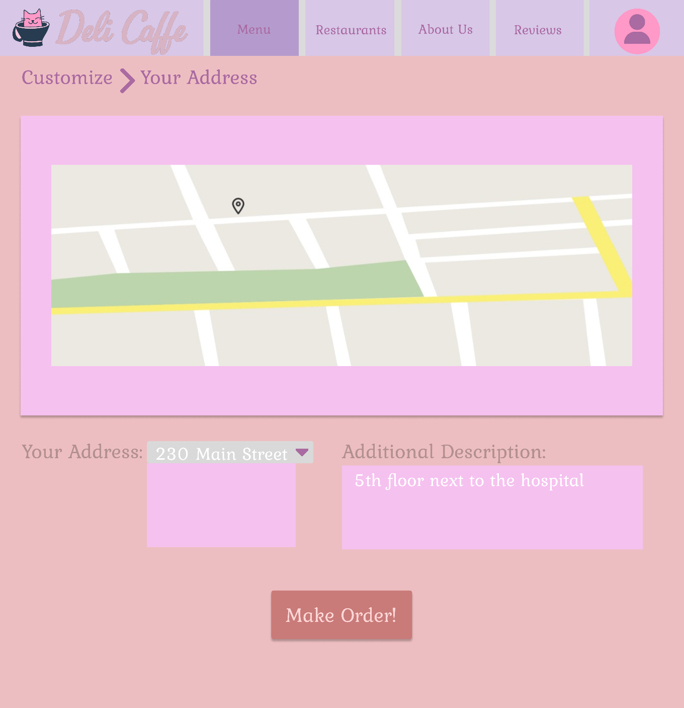

Confirmation

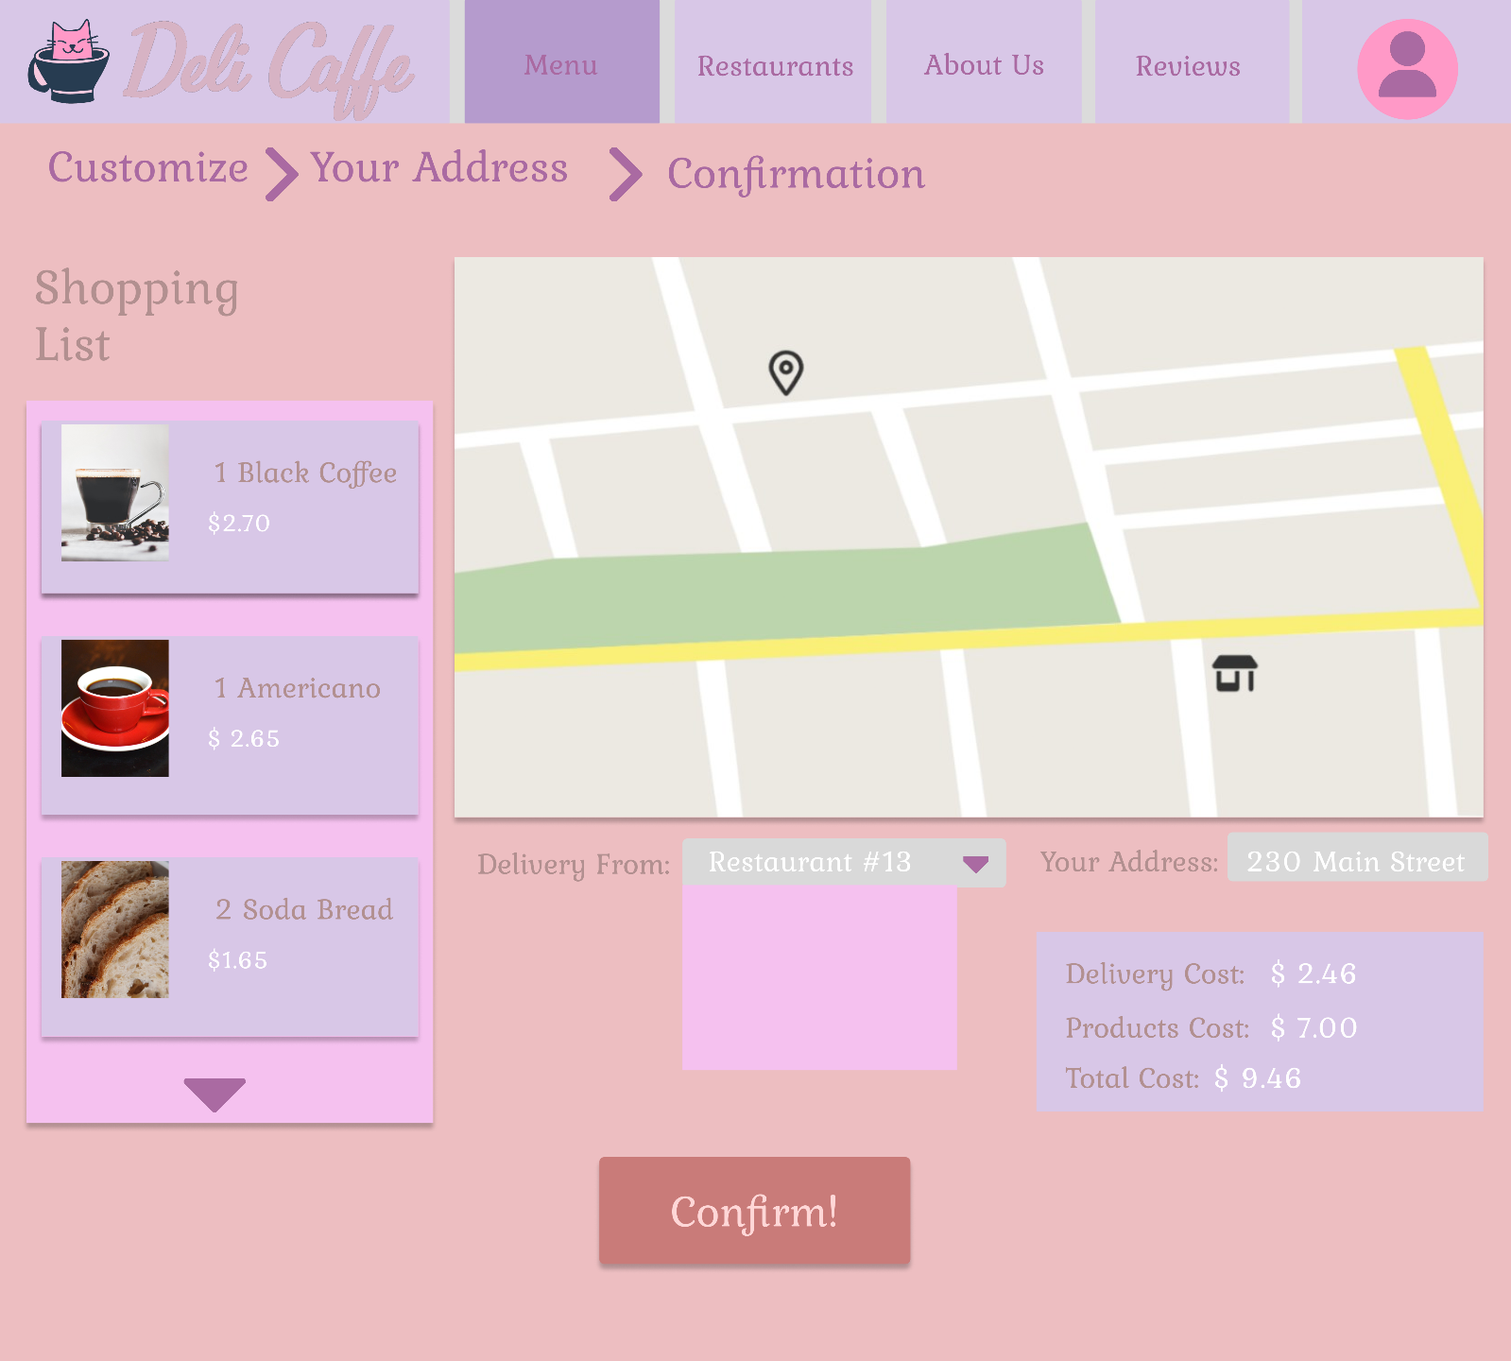

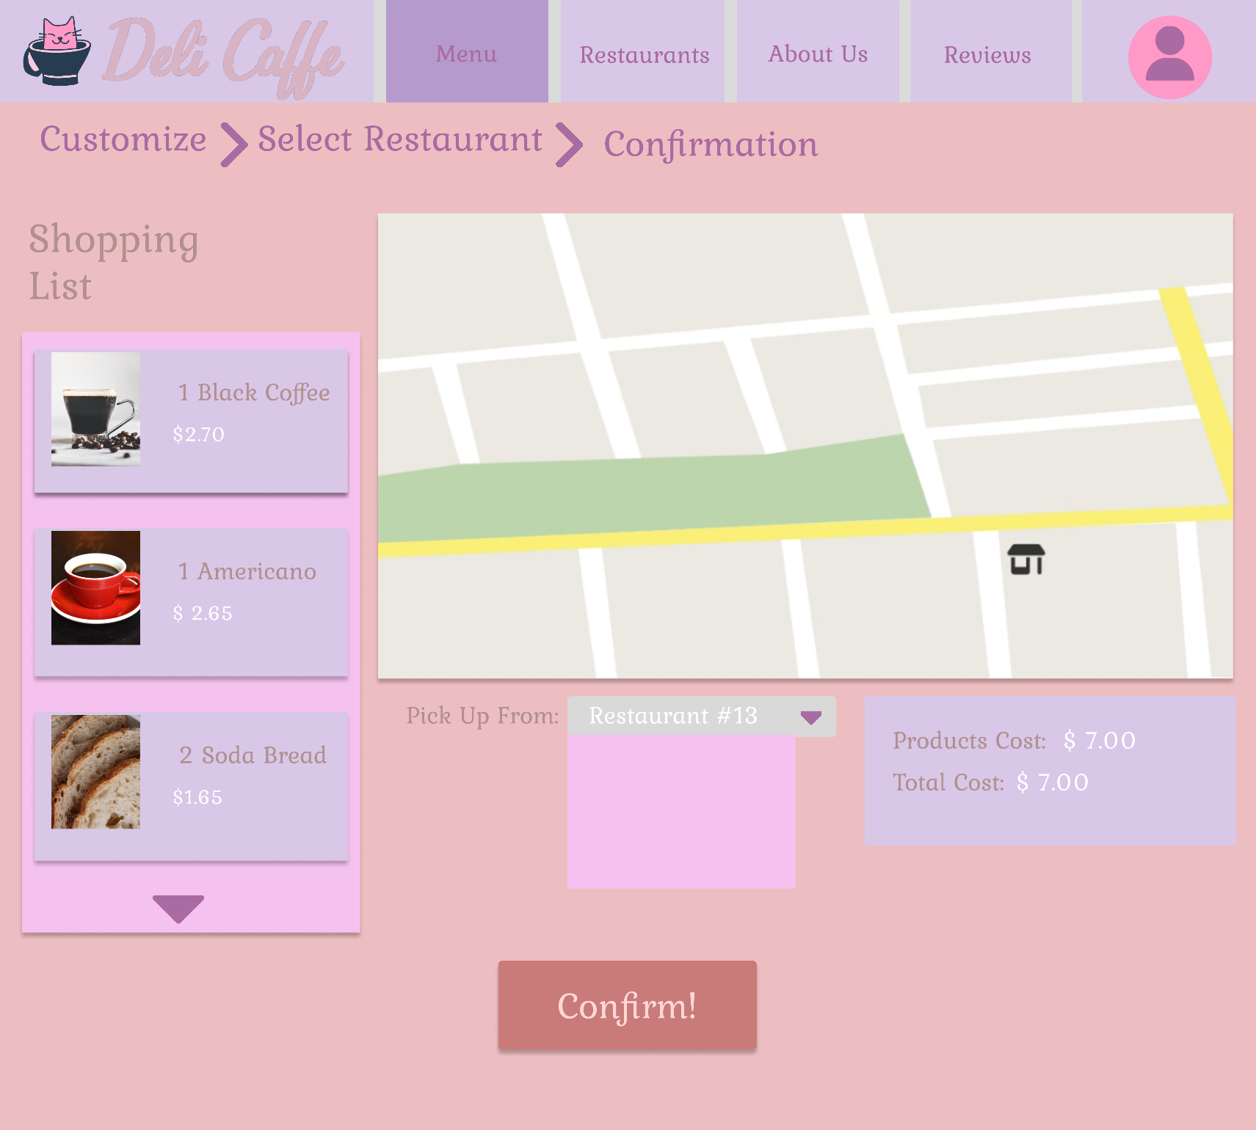

Restaurants

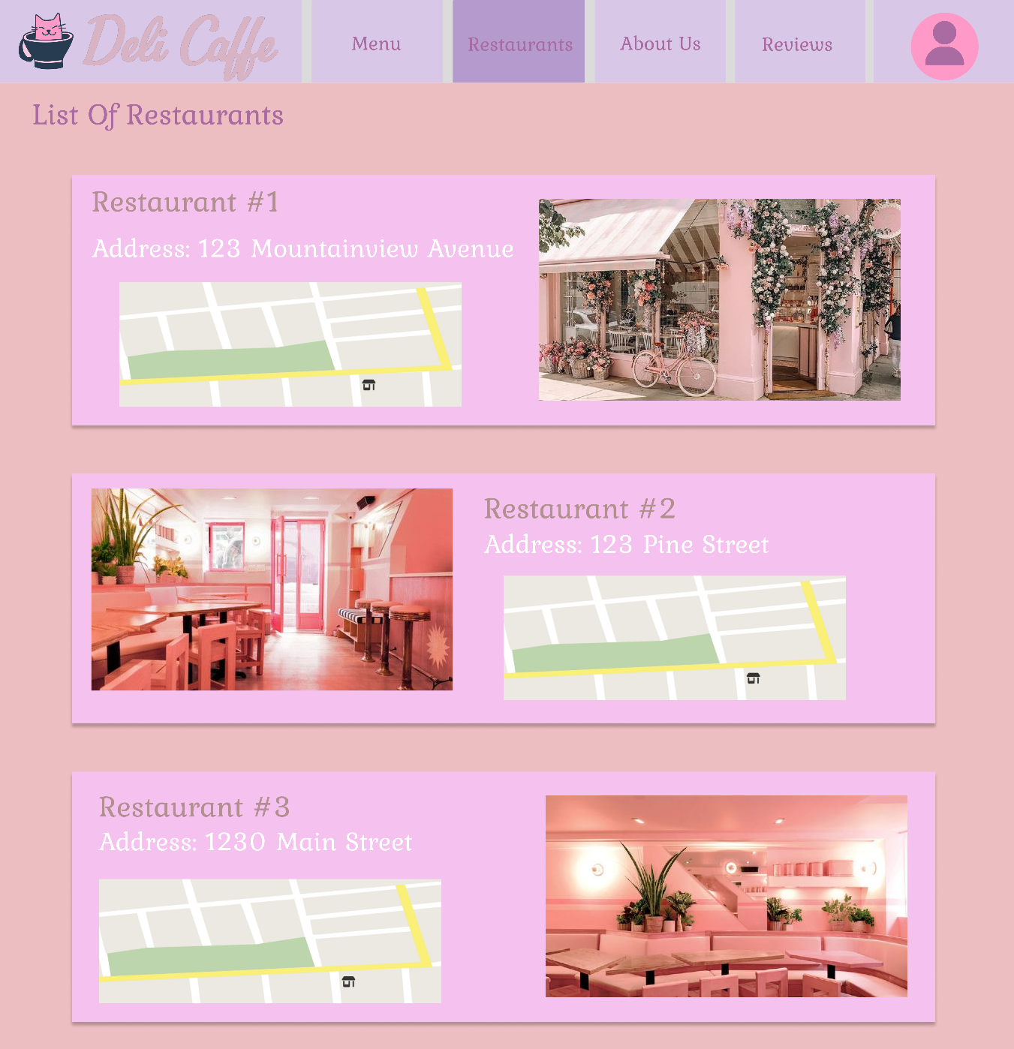

About Us

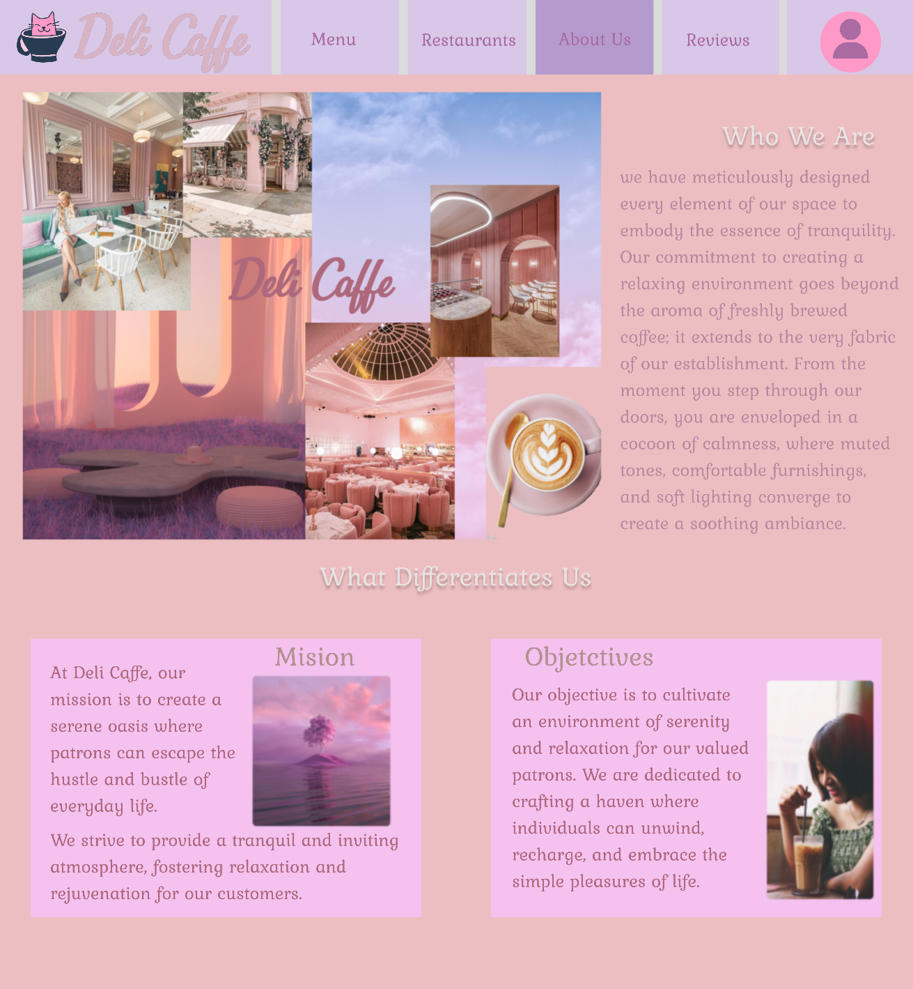

Reviews

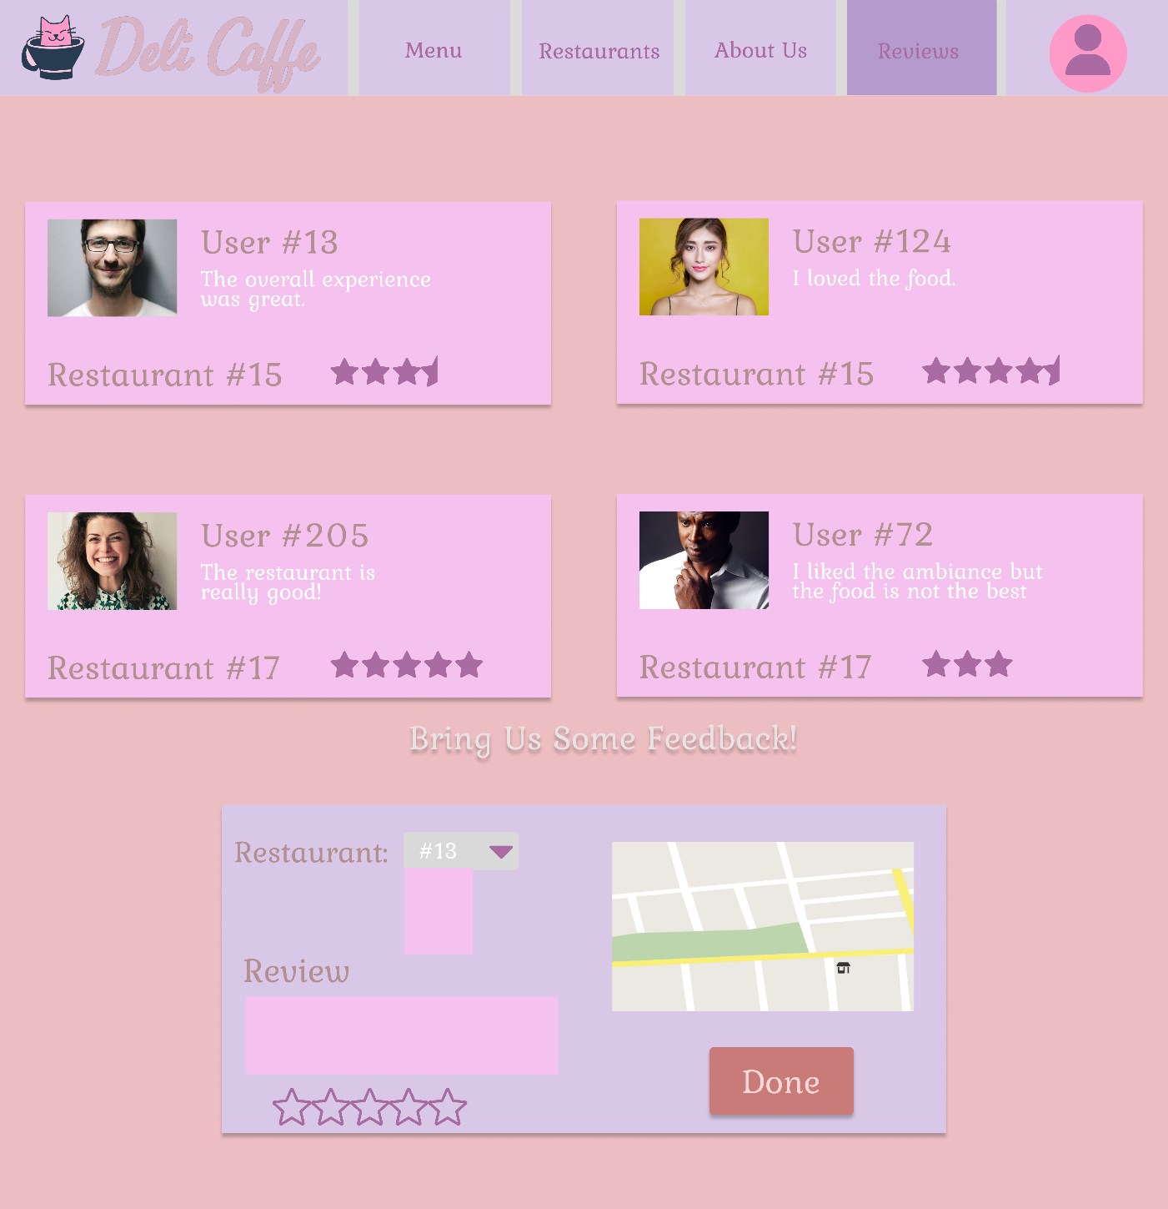

Account

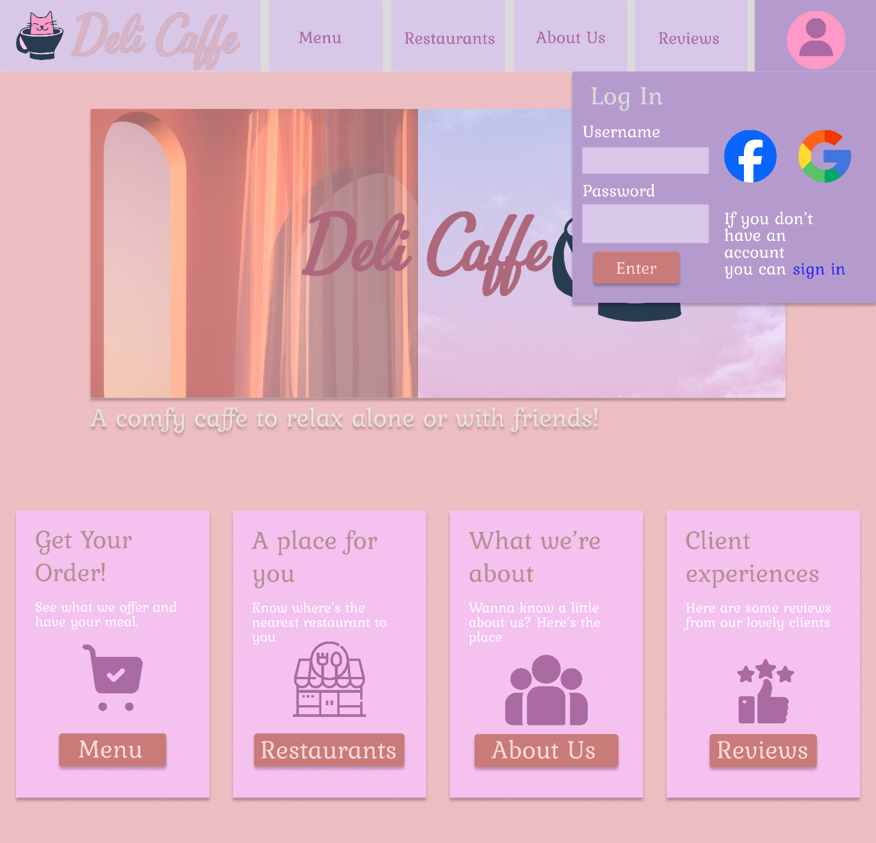

Order History

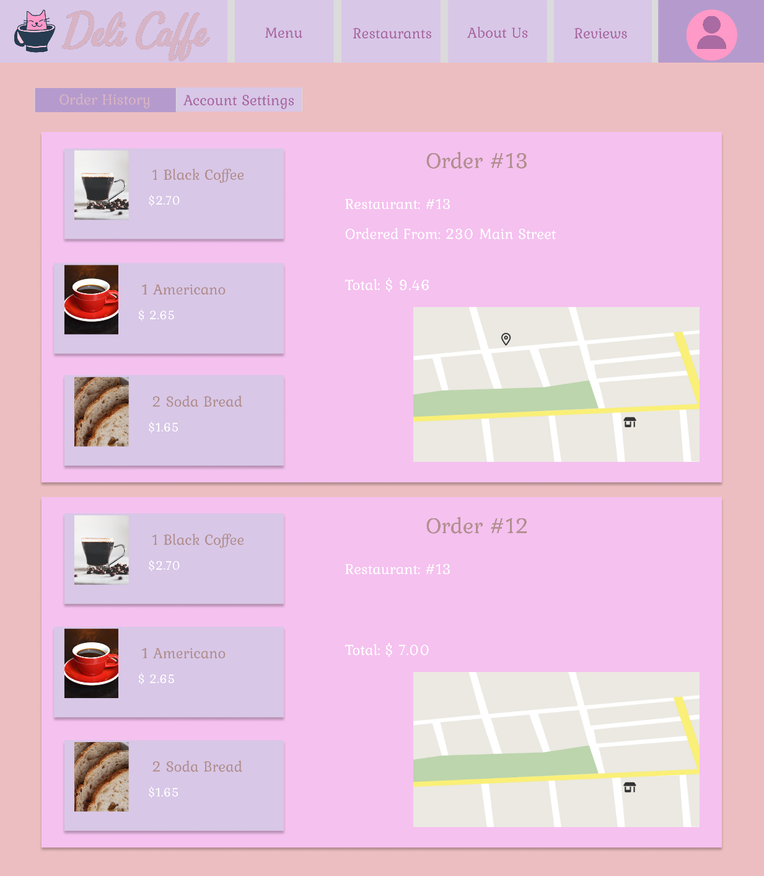

Account Settings

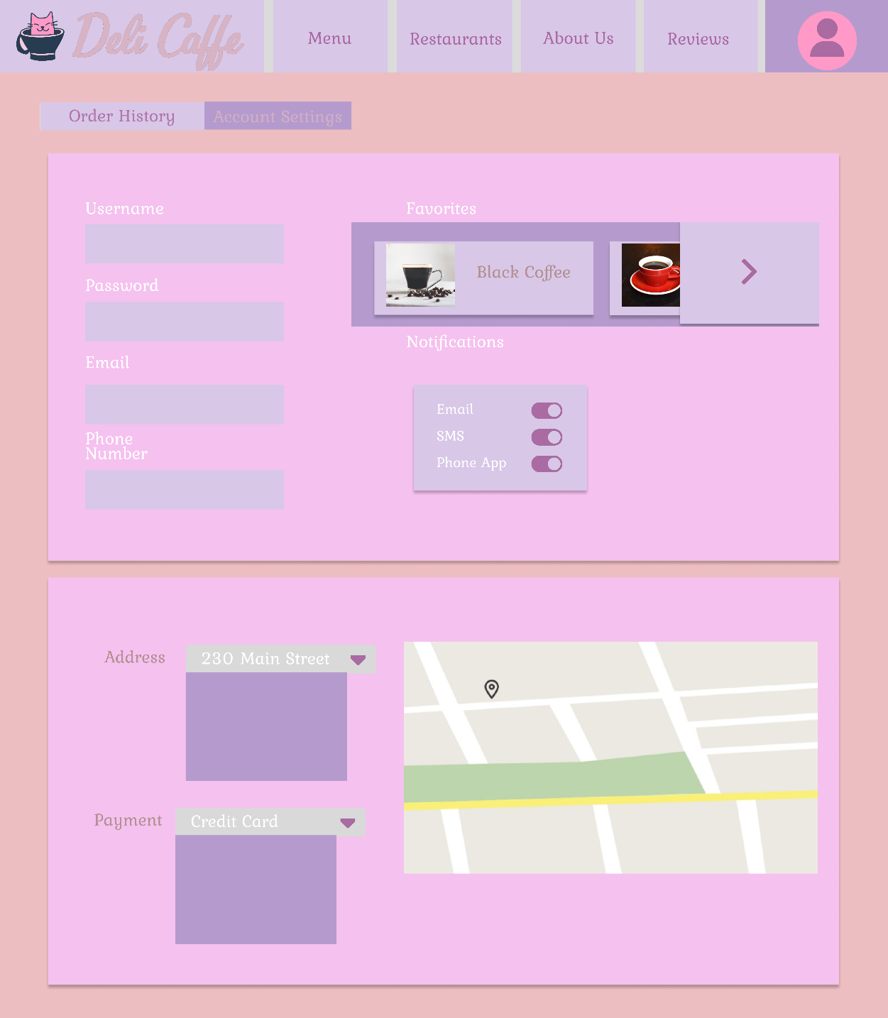

Sign In Form

